

**DEPARTMENT OF ELECTRICAL AND COMPUTER ENGINEERING**

**EEL-4921C**

**SENIOR DESIGN II FINAL REPORT**

**Spring 2016**

**Smart Home System with Voice Command “Alfred”**

**TEAM 20**

Roy Lara 4267659 [rlara018@fiu.edu](mailto:rlara018@fiu.edu)

Angela Layne 1886523 [alayn001@fiu.edu](mailto:alayn001@fiu.edu)

Ariel Romero 4954259 [arome089@fiu.edu](mailto:arome089@fiu.edu)

Patricia Sopena 5319793 [psope001@fiu.edu](mailto:psope001@fiu.edu)

**Mentor: Dr. Gustavo Roig**

**April**

**2016**

***Table of Contents***

ABSTRACT 8

I. EXECUTIVE SUMMARY 8

*Objectives* 9

*Constraints* 9

*Background* 10

*Ethical Consideration* 10

*End Product Description* 11

*Budget* 11

II. PROBLEM STATEMENT 12

*A.* *Project Objectives* 12

*B.* *Constraints* 12

III. ASSUMPTIONS AND LIMITATIONS 12

*A.* *Assumptions* 12

*B.* *Limitations* 13

IV. NEEDS FEASIBILITY ANALYSIS 13

*A.* *Needs Analysis* 13

*B.* *Need Specification* 19

*C.* *Feasibility Analysis* 23

1. Types of Feasibility 23

2. Feasibility Assessment 26

*D.* *Marketability* 35

1. Domus Affordable Smart Home Automation Solution 36

2. The Future of Smart Home - B.One 39

V. RISK ANALYSIS 44

*A.* *Types of Feasibility* 44

*B.* *Risk Assessment* 46

*C.* *Exposure Matrix* 47

VI. OPERATING ENVIRONMENT 48

VII. INTENDED USER(S) AND INTENDED USE(S) 48

*A.* *Intended User(s)* 48

*B.* *Intended Use(s)* 49

VIII. BACKGROUND 49

*A.* *VOCCA* 49

*B.* *Homey* 52

*C.* *NEEO* 55

IX. INTELLECTUAL PROPERTY 60

*A.* *Automation Control of Electronic Devices, US 9,152,139 B2* [7] 60

*B.* *Voice Control Device and Voice Control Method US 9,153,232 B2* [8] 62

*C.* *Actuator for Electric Blinds, US 4,773,464 [9]* 63

X. STANDARDS CONSIDERATIONS 64

XI. GLOBALIZATION 65

*A.* *World Trade Organization* 65

*B.* *Importance of Eliminating the Barriers to Trade* 66

*C.* *Collaboration Tools* 67

*D.* *Perspective of our product in different countries and cultures* 67

XII. HEALTH AND SAFETY 68

XIII. ENVIROMENTAL CONSIDERATIONS 68

XIV. SUSTAINABILITY CONSIDERATIONS 69

XV. MANUFACTURABILITY CONSIDERATIONS 70

XVI. ETHICAL CONSIDERATIONS AND SOCIAL IMPACT 71

*A.* *Ethical Considerations* 71

*B.* *Social Impact* 72

XVII. CONCEPT DEVELOPMENT 74

*A.* *Concept Combination 1* 75

*B.* *Concept Combination 2* 76

*C.* *Concept Combination 3* 77

*D.* *Concept Selection* 77

XVIII. END PRODUCT DESCRIPTION AND OTHER DELIVERABLES 79

*A.* *End Product Description* 79

XIX. PLAN OF ACTION 87

XX. MULTIDISCIPLINARY ASPECTS 95

XXI. PERSONNEL 96

*A.* *Roy Lara* 96

*B.* *Angela Layne* 97

*C.* *Patricia Sopena* 98

D. *Ariel Romero* 99

XXII. BUDGET 100

XXIII. RESULTS EVALUATION 103

*Standards Consideration* 104

*Standards Consideration* 106

XXIV. LIFE LONG LEARNING 107

XXV. CONCLUSION 108

APPENDIX A 110

APPENDIX B 111

APPENDIX C 112

BIBLIOGRAPHY 115

SIGNING PAGE 117

Figure 1 9

Figure 3 – Brainstorm 14

Figure 4 - BUD Industries JBH-4958-KO 21

Figure 5 38

Figure 6 - Smart socket 39

Figure 7 - Smart iCon 39

Figure 8 - B.One Smart Hub 43

Figure 9 44

Figure 10 46

Figure 11 51

Figure 12 51

Figure 13 53

Figure 14 53

Figure 15 54

Figure 16 55

Figure 17 59

Figure 18 60

Figure 19 61

Figure 20 62

Figure 21 63

Figure 22 70

Figure 23 73

Figure 24 74

Figure 25 79

Figure 26 81

Figure 27 82

Figure 28 83

Figure 29 84

Figure 31 86

Figure 32 87

Figure 33 – PERT Diagram 91

Figure 34 – WBS Proposed 92

Figure 35 – WBS Final 92

Table 1 - Attributes from client interview, survey and brainstorm 15

Table 2 16

Table 3 16

Table 4 17

Table 5 17

Table 6 18

Table 7 - Competitive Benchmark 20

Table 8 22

Table 9 26

Table 10 27

Table 11 27

Table 12 28

Table 13 29

Table 14 30

Table 15 30

Table 16 31

Table 17 31

Table 18 32

Table 19 33

Table 20 34

Table 21 34

Table 22 34

Table 23 35

Table 24 - Weighted Scale 35

Table 25 37

Table 26 41

Table 27 41

Table 28 42

Table 29 42

Table 30 42

Table 31 43

Table 32 - Exposure Matrix 47

Table 33 47

Table 34 50

Table 35 56

Table 36 56

Table 37 56

Table 38 57

Table 39 57

Table 40 57

Table 41 57

Table 42 57

Table 43 58

Table 44 58

Table 45 58

Table 46 58

Table 47 58

Table 48 59

Table 49 59

Table 50 75

Table 51 76

Table 52 77

Table 53 77

Table 54 78

Table 55 78

Table 56 80

Table 57 81

Table 58 83

Table 59 83

Table 60 84

Table 61 85

Table 62 86

Table 63 87

Table 64 – Proposed Task Chart 88

Table 65 – Final Task Chart 89

Table 66 – Proposal Gantt Chart 90

Table 67 – Completed Project Gantt Chart 91

Table 68 – Proposed Budget 101

Table 69 – Final Budget 102

Table 70 105

Table 71 107

ABSTRACT

“Alfred”, the smart home system is a simple and easy to use house automation control system. It is friendly for all ages and allows the users to control lights, garage doors, make phone calls, and checks the status of doors and windows, with a voice user interface or through a smart phone application. This system makes life easier and more comfortable, especially for the elderly and the disable. This is a study on the most cost efficient design to implement a smart home automation system that communicates wirelessly and through a voice recognition user interface. With the current existing readily available modules on the market, we chose the Arduino Mega 2560 and an EasyVR shield to add voice functionality to the system. A simple installation and programmed command set was all that was needed to realize the voice recognition feature. Choosing to transmit via WiFi, the Dragino Yun Shield implements an OpenWRT Linux on top of the board with Ethernet capabilities. It communicates to a custom made android mobile application for all android smart phones. The design was also evaluated for the most beneficial power usage, cycling through the possible circuit designs until finally deciding on Triacs. This system supports the hypothesis of an efficient design of a voice recognizing wireless home controller.

**ALFRED**

Automated living, friendly Robotic Environment Director

1. EXECUTIVE SUMMARY

|  |  |
| --- | --- |
| Smart Home System with Voice Command “Alfred” | |
| Team Number: 20 | Team Name: The Owls |
| Mentor: Dr. Gustavo Roig | Team Leader: Ariel Romero |
| Team Member: Roy Lara | Team Member: Patricia Sopena |
| Team Member: Angela Layne | Team Member: |

## Summarized Problem Statement

This project is about designing an affordable voice commanded smart home system. The system is able to control the lights of at four areas of your house. Also, the system opens and closes the garage door, besides checking the status of the remaining doors and windows. To make the system user friendly for all ages, it is able to make phone calls not only to the emergency service but also to the favorite contacts. Since the system is not only operated by an app, but also by voice commands the user can reprogram the voice commands to their favorite choice personalizing the system. All these functions controlled by one single piece of equipment with no necessity of additional devices.

## Objectives and Constraints

*Objectives*

The objective of this project was to create an affordable smart home system using existing technology that will make life easier, not only for those who use the application on a smart phone, but also to those who are not so adept to technology. The system is able to perform some basic functions like turning on and off lights via voice command or smart phone, among other objectives listed below.

The main objectives of the project are:

1. The system is able to control lights from a variety of areas.
2. The system controls the garage door.
3. The system checks the doors and windows status.
4. The system is able to make phone calls.
5. The system has a moderate grade of installation difficulty.

*Constraints*

Our smart home system has constraints that created limitations on it. However, those limitations did not make it impossible to build it and are only challenges that were overcome. The constraints that we encountered in the development of our system are listed below.

The constraints of the project are:

1. The system needed to be operable by voice, phone application and regular switches.
2. The system needed to be small enough to fit in a closet or attic.
3. The system needed to be one device.

## Project Description

Loved ones are left at home, the elders of our households, even those with some kind of disabilities; and sometimes is difficult for them to reach a light switch, or in case of an accident to dial a phone. What if a smart home system was made not only for people who loves technology but also for elders?  A system that’s easy to use, with the ability to understand your voice commands and also a phone app for your smart phone or tablet to control it.

We have created a voice command system that is directly connected to your home infrastructure in order to allow any homeowner (including those with disabilities) to access their house. Our design allows anyone to turn on or off the light of his or her house, make a phone call in case of an emergency. Also, users that are more comfortable using a phone application can manage every aspect of the system through the app, even check the status of the doors and windows and control their garage doors from their phone app and also through the voice command.

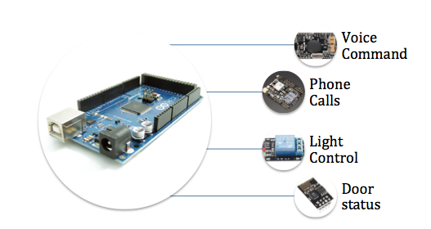

Figure 1

## Sections

*Background*

Upon researching competing products that are already in the market. Listed below are three products, giving a simple glimpse of what the current state of the art on smart home automation control systems.

***VOCCA***

The VOCCA is an available technology developed by a team from Tel Aviv, Israel integrated by: Erez Nimrod, Ori Indursky, Vladislav Serebnik, Adi Malik, Ofer Masamy, Maggi Yovov, and Nir Dvash [4]. VOCCA is a smart lighting system, which does not required Wi-Fi, professional setup, or installation since it is a simple plug and play voice activated bulb adapter.

***HOMEY***

Homey is a voice-controlled home automation technology that allows you to talk to your room. A large team from Enschede, Netherlands developed it with over 15 members (Athom) [5]. Homey is described as a personal assistant that will help make a home more personal, since it is designed to control “from lights to music, from climate to TV.” The possibilities of this device are many, especially combining functions; for example, it is able to sync the light and the coffee machine with the alarm clock, making the user’s morning an incredible experience.

***NEEO***

NEEO, the Thinking Remote is a revolutionary remote that allows home automation by hand recognition. It was co-founded by Raphael Oberholzer (CEO) and Oliver Studer (CTO) of NEEO Inc [6]. NEEO is a smart home automation system that connects and controls the devices of the house in very simple way. Instead of having a control remote for every device, this technology enables the user to have only one control for all of them

*Ethical Consideration*

When the team starts developing the idea of our Smart Home System “Alfred”, one of the first objectives that comes to our mind was the desire of improving the quality of life of elderly and disable people. But we were aware that the use of human interfaces in the design of the smart home system could present several ethical issues, even more if the system is meant to be also used by people with any kind of disability of restriction (physical, cognitive, or sensorial). Therefore we were extremely careful with the design of the system; we develop the interface having in mind that all type of people could be accessing to the system, in that way we treat fairly all persons regardless of such factors as race, religion, gender, disability, age, or national origin. In the process of the design we also sought and accepted honest criticism of our technical work; we acknowledged and corrected errors, and credited the contributions of others. As new developers of technology, the assistance of our mentor was essential to achieve an improved project.

*End Product Description*

Our end product is enclosed in a nice, safe, operable electrical box with dimensions of 8” width x 10” Height x 4” Depth that you can install in a utility closet or attic. Inside the box the user will find a different layers system controlled by an Arduino Mega 2560 board that is going to be connected to the house infrastructure. The system comprises different layers or modules, for example, a voice command shield with a 3.5mm audio output jack and a 8 ohm speaker output, a FONA 800 Voice/Data GSM module, a Triac board, a relay board, magnetic contact switches in doors and windows couple to the Arduino, a Wi-Fi Module to communicate with its phone application. All these components working as a single unit with different microphones around the house will give the user the ability to control the lights and garage doors trough their voice, phone or regular switches; also, make calls and check the doors and windows status. Since our system will be a single unit, the use of a technician is recommended in order to evaluate your house and install the product.

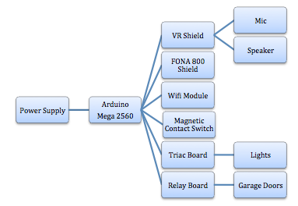Figure 2

*Budget*

Every development project needs to be an analysis of all expenses that it could have during the concept, design, testing, and production; in other words a deep look into the budget. The budget includes every single expense: charges for team member’s work, the use of labs, and the cost of all components. The budget shouldn’t be obtained by intuition; it has to be a result of the use of a project planning software. After entering all the information in the software used (Open Workbench), we obtained the estimated found needed in order to bring our project to live. To develop our system it costs us $6,488.80 USD.

The Smart Home system with voice commands that we have created, is able to perform basic operations like turning on and off the lights, opening the garage door and making phone calls using voice commands from the user. Like any other electronic system there were some constraints that we encountered, however none of the constraints made it impossible for us to build and implement our system, not even the existing patents since we did not infringing in any of them. Also, the budget makes our system affordable once we build and get our system in the market.

1. PROBLEM STATEMENT

This project is about designing an affordable voice commanded smart home system. The system is able to control the lights of at least four areas of your house. Also, the system is able to open and close the garage door, besides checking the status of the remaining doors and windows. To make the system user friendly for all ages, it is able to make phone calls not only to the emergency service but also to the favorite contacts. Since the system is not only operated by an app, but also by voice commands the user can reprogram the voice commands to their favorite choice personalizing the system. All these functions are controlled by one single piece of equipment with no necessity of additional devices.

1. *Project Objectives*
2. Controlled Areas

1.1 The system should be able to controls the garage door

1.2 Most important areas to control light; bedroom, living room and kitchen

1. Safety
   1. The system should be able to perform emergency calls, and to favorite contacts
   2. The system should be able to check the doors and windows to see if they are open or close.
2. Interaction
   1. The system will confirm your voice commands with a tone.
   2. The system could be reprogrammable with voice commands of your choice.
3. Marketability
   1. The system should have a moderate grade of installation difficulty.
4. *Constraints*
5. The system should be operable by voice, phone application and regular switches.
6. The system should be small enough to fit in a closet or attic.
7. The system should be one device.
8. ASSUMPTIONS AND LIMITATIONS
9. *Assumptions* 
   1. The prototype will be finished by April 2016.
   2. All team members will be able to contribute to the project.
   3. The total cost in parts for the product development will not exceed $250.00 USD.
   4. The customer will set up the product in a closet or attic.
   5. The customer will have Internet in the house.
10. *Limitations*
11. Maximum of two garage doors to be controlled.
12. At least one 120-volt outlet will be available to feed the unit.
13. The end-user will need a PC in order to modify the voice command program.
14. NEEDS FEASIBILITY ANALYSIS
15. *Needs Analysis*

The need analysis section will describe step by step how project’s objectives, constraints and the problem statement are developed.

The first step in the need analysis process is to conduct an interview with our client in order to define the client’s needs. Below you can find our interview questionnaire and the answers from our client.

### Client Interview:

1. What kind of features would you like to see in a smart home automation system?

* App
* Calls
* Garage door
* Security (Check doors and windows to see if they are open)

1. While inside your house for the system to communicate with you, would you like a voice or a small smooth tone that confirm your commands?

* Tone

1. Would you be willing to contact a licensed electrician if you don’t want to install the system?

* Yes

1. What would you be willing to pay for such technology?

* $ 400.00 USD

1. What appliances and other household items would you like to see a smart solution for?

* Garden Lights
* Kitchen appliances

1. What do you like about the existing products?

* To be able to check if my house windows and doors are closed through my phone app.

1. Take me through a day of using this technology.

When I wake up early in the morning I would tell my bedroom lights to turn on, than go to the bathroom and do the same, I get ready to go to work and as I walk through the house I will turn on the light where needed. When I am going to leave I would tell the garage door to open so I can take out the car, after I leave the house for security purposes I will use my phone app to close the garage door and turn on the alarm system.

The second step is to conduct a survey to our potential customers, to identify the user’s needs. The survey is included, along with the results, in Appendix C.

The third step is a team brainstorm where we analyze the interview and the survey and add new needs to our project that were not presented before.

**Brainstorm:**

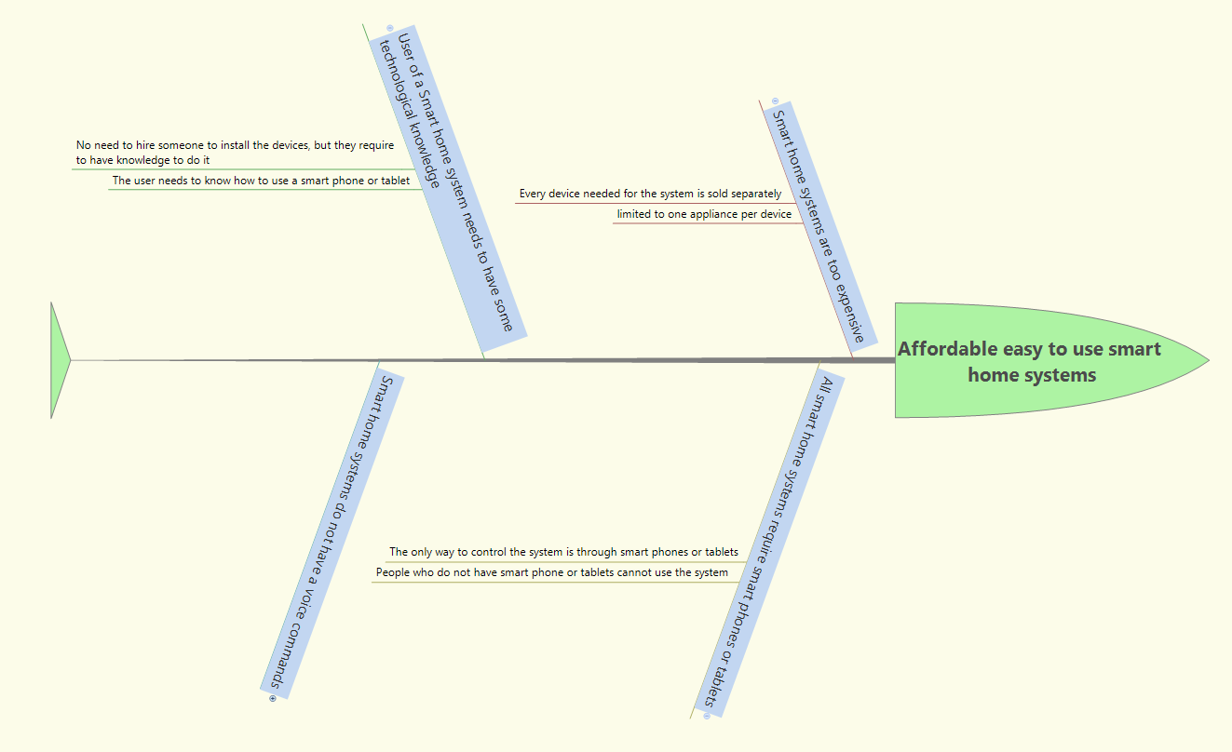

Figure 3 – Brainstorm

* Make the system one device and not sale it separately
* Easy to use, can hire someone to install it, and the user does not need to have any technical knowledge
* The system does not require to have a smart home or tablet if the user does not want, since it can be use through voice commands.
* Our smart home system will be able to make phone calls not only for emergencies like 911 but also to our favorite contacts.
* The system should be small enough to fit in a closet or attic
* The system should be able to control the garden lights
* The system could be reprogrammable with voice commands of your choice

Now we are going to list all the attributes collected from the client interview, the survey and the brainstorm. Remove the repeated entries and eliminate constraints, functions and implementations. Finally we order the objectives by similar categories and the result will be a pruned list of objectives shown below.

The fourth step is determining attributes from client interview, survey and brainstorm.

|  |  |
| --- | --- |
| **Source** | **Attributes** |
| Client | The system should be operable by voice, phone application and regular switches. |
| Client | The system should be able to controls the garage door |
| Client | The system should be able to perform emergency calls, and to favorite contacts |
| Client | The system should be able to check the doors and windows to see if they are open or close. |
| Client | The system will confirm your voice commands with a tone |
| Client | The system could have a retail price of $400.00 USD |
| Survey | Most important areas to control light; bedroom, living room and kitchen. |
| Survey | The system should have a moderate grade of installation difficulty |
| Survey | The system should be operable by voice, phone application and regular switches. |
| Survey | The system could have a retail price around $300.00 USD |
| Survey | The system should be able to perform calls. |
| Brainstorm | The system could be reprogrammable with voice commands of your choice |
| Brainstorm | The system should be able to control the garden lights |
| Brainstorm | The system should be one device |
| Brainstorm | The system should be small enough to fit in a closet or attic |

Table 1 - Attributes from client interview, survey and brainstorm

The fifth step is identifying and removing repeated entries.

|  |  |
| --- | --- |
| **Source** | **Attributes** |
| Client | The system should be operable by voice, phone application and regular switches. |
| Client | The system should be able to controls the garage door |
| Client | The system should be able to perform emergency calls, and to favorite contacts |
| Client | The system should be able to check the doors and windows to see if they are open or close. |
| Client | The system will confirm your voice commands with a tone |
| Client | The system could have a retail price of $400.00 USD |
| Survey | Most important areas to control light; bedroom, living room and kitchen. |
| Survey | The system should have a moderate grade of installation difficulty |
| Survey | The system should be operable by voice, phone application and regular switches. |
| Survey | The system could have a retail price around $300.00 USD |
| Survey | The system should be able to perform calls. |
| Brainstorm | The system could be reprogrammable with voice commands of your choice |
| Brainstorm | The system should be able to control the garden lights |
| Brainstorm | The system should be one device |
| Brainstorm | The system should be small enough to fit in a closet or attic |

Table 2

Repeated are eliminated:

|  |  |
| --- | --- |
| **Source** | **Attributes** |
| Client | The system should be able to controls the garage door |
| Client | The system should be able to perform emergency calls, and to favorite contacts |
| Client | The system should be able to check the doors and windows to see if they are open or close. |
| Client | The system will confirm your voice commands with a tone |
| Client | The system could have a retail price of $400.00 USD |
| Survey | Most important areas to control light; bedroom, living room and kitchen. |
| Survey | The system should have a moderate grade of installation difficulty |
| Survey | The system should be operable by voice, phone application and regular switches. |
| Survey | The system could have a retail price around $300.00 USD |
| Brainstorm | The system could be reprogrammable with voice commands of your choice |
| Brainstorm | The system should be able to control the garden lights |
| Brainstorm | The system should be one device |
| Brainstorm | The system should be small enough to fit in a closet or attic |

Table 3

The sixth step is eliminating functions, constraints and implementations.

|  |  |  |
| --- | --- | --- |
| **Source** | **Attributes** |  |
| Client | The system should be able to controls the garage door |  |
| Client | The system should be able to perform emergency calls, and to favorite contacts |  |
| Client | The system should be able to check the doors and windows to see if they are open or close. |  |
| Client | The system will confirm your voice commands with a tone |  |
| Client | The system could have a retail price of $400.00 USD |  |
| Survey | Most important areas to control light; bedroom, living room and kitchen. |  |
| Survey | The system should have a moderate grade of installation difficulty |  |
| Survey | The system should be operable by voice, phone application and regular switches. | Constrain |
| Survey | The system could have a retail price around $300.00 USD |  |
| Brainstorm | The system could be reprogrammable with voice commands of your choice |  |
| Brainstorm | The system should be able to control the garden lights |  |
| Brainstorm | The system should be one device | Constrain |
| Brainstorm | The system should be small enough to fit in a closet or attic | Constrain |

Table 4

Table with eliminated functions constraints and implementations

|  |  |
| --- | --- |
| **Source** | **Attributes** |
| Client | The system should be able to controls the garage door |
| Client | The system should be able to perform emergency calls, and to favorite contacts |
| Client | The system should be able to check the doors and windows to see if they are open or close. |
| Client | The system will confirm your voice commands with a tone |
| Client | The system could have a retail price of $400.00 USD |
| Survey | Most important areas to control light; bedroom, living room and kitchen. |
| Survey | The system should have a moderate grade of installation difficulty |
| Survey | The system could have a retail price around $300.00 USD |
| Brainstorm | The system could be reprogrammable with voice commands of your choice |
| Brainstorm | The system should be able to control the garden lights |

Table 5

Steps seventh, pruned list of objectives organized by categories.

|  |  |  |
| --- | --- | --- |
| **Source** | **Attributes** | **Categories** |
| Client | The system should be able to controls the garage door | Controlled Areas |
| Survey | Most important areas to control light; bedroom, living room and kitchen. | Controlled Areas |
| Brainstorm | The system should be able to control the garden lights | Controlled Areas |
| Client | The system should be able to perform emergency calls, and to favorite contacts | Safety |
| Client | The system should be able to check the doors and windows to see if they are open or close. | Safety |
| Client | The system will confirm your voice commands with a tone | Interaction |
| Brainstorm | The system could be reprogrammable with voice commands of your choice | Interaction |
| Survey | The system should have a moderate grade of installation difficulty | Marketability |
| Survey | The system could have a retail price between $300.00 and $400.00 USD | Marketability |

Table 6

**Problem Statement**

This project is about designing an affordable voice commanded smart home system. The system should be able to control the lights of at least five areas of your house. Also, the system should be able to open and close the garage door, besides checking the status of the remaining doors and windows. To make the system user friendly for all ages, it will be able to make phone calls not only to the emergency service but also to the favorite contacts. Since the system is not only operated by an app, but also by voice commands the user can reprogram the voice commands to their favorite choice personalizing the system. All these functions controlled by one single piece of equipment with no necessity of additional devices.

**Project Objectives**

1. Controlled Areas

1.1 The system should be able to controls the garage door

1.2 Most important areas to control light; bedroom, living room and hallway

1. Safety
   1. The system should be able to perform emergency calls, and to favorite contacts
   2. The system should be able to check the doors and windows to see if they are open or close.
2. Interaction
   1. The system will confirm your voice commands with a tone.
   2. The system could be reprogrammable with voice commands of your choice.
3. Marketability
   1. The system should have a moderate grade of installation difficulty.

**Constraints**

1. The system should be operable by voice, phone application and regular switches.
2. The system should be small enough to fit in a closet or attic.
3. The system should be one device.
4. *Need Specification*

In this section we are going to analyze the objectives and problem statement and translate them into engineering language. Also, we will check our design operating environment and certain conditions in which our system will be exposed. This and some assumptions made by our team will lead to new specifications in our design.

**Controlled Areas**

1. The system should be able to control the lights of at least five areas of your house

2. The system should be able to open and close the garage door.

The system will use an Arduino Mega 2560 board with at least five relays that each will handle between 10 to 20 amps of current. That way with a low voltage signal of 5 volts we can control different lights and the garage door.

**Safety**

1. The system should be able to perform emergency calls, and to favorite contacts.

2. The system should be able to check the doors and windows to see if they are open or close.

The system will use a FONA 800 Shield - Voice/Data Cellular GSM for Arduino. It has a Quad-band 850/900/1800/1900MHz. Capable to make and receive voice calls using an external 8Ω speaker + electret microphone. Also, the Arduino Mega 2560 coupled with magnetic contact switches will make the system able to check the status of your doors and windows.

**Interaction**

1. The system will confirm your voice commands with a tone.

2. The system could be reprogrammable with voice commands of your choice.

The system will have a voice recognition module that includes a command to process and download custom sound tables. Also it will Provides a 3.5mm audio output jack suitable for headphones or as a line out, and an 8 ohm speaker output.

**Marketability**

1. The system should have a moderate grade of installation difficulty.

2. The system could have a retail price between $300.00 and $400.00 USD

Since the system will be a single unit, the use of a technician is recommended in order to evaluate your house and install the product. Also, based on our client interview, survey and competitive products on the market our system can be sold starting in a price of $300.00 USD for a standard system.

**Competitive Benchmark**

|  |  |  |  |
| --- | --- | --- | --- |
|  | **Insteon** | **Lutron** | **Our design** |
| Controlled areas | 2 lights 1 Door / Window security sensor, possibilities to expand. | 4 lights, possibilities to expand | 5 lights, garage door control, 1 Door / Window security sensor |
| Able to make calls | No | No | Yes |
| Single or multiple devices | Multiple | Multiple | No, only one device |
| Voice command capability | No | No | Yes |
| Cost | $369.99 USD | $356.00 USD | $350.00 USD |

Table 7 - Competitive Benchmark

**Constrains**:

1. The system should be operable by voice, phone application and regular switches.

2. The system should be small enough to fit in a closet or attic.

3. The system should be one device.

The system will be connected to your house’s lights infrastructure, so your regular switches will be available. As well as a smartphone application that allows you to interact with the system when you are not at home. Also, a variety of microphones will be installed around your house, so you can interact with the system through your voice. Microphone sensitivity -38dB (0dB=1V/Pa @1KHz), load Impedance 2.2K, operating voltage 3V, almost flat frequency response in the range 100Hz – 20 kHz. The microphones could be set for short or large range. Finally, different layer like voicing system, calling module and relays boards will be assembled into a single smart unit. It will be preinstalled and enclosed in an electrical box ready for you.

Tentative Dimensions 8” width x 10” Height x 4” Depth

Box from BUD industries JBH-4958-KO

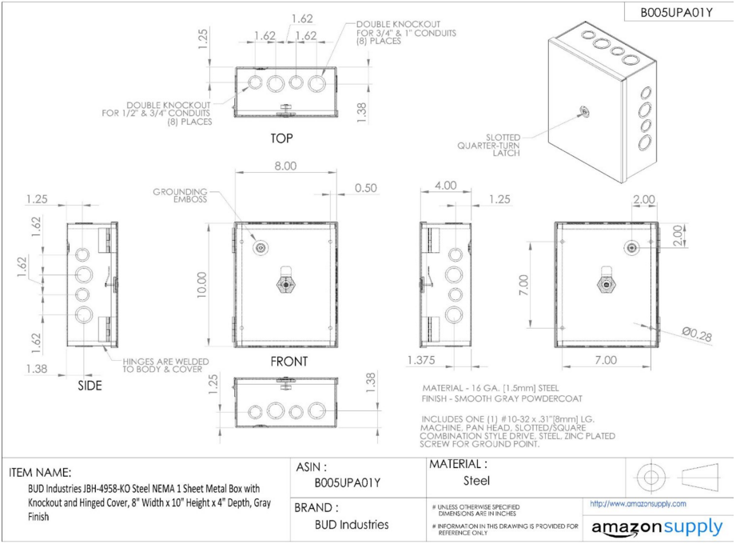

Figure 4 - BUD Industries JBH-4958-KO

**Assumptions and Limitations**

Assumptions:

1. The prototype will be finished by March 2016

2. All team members will be able to contribute to the project.

3. The total cost in parts for product development will not exceed $250.00 USD

4. The customer will set up the product in a closet or attic.

5. The customer will have Internet in the house.

Limitations:

1. Maximum of two garage doors to be controlled.

2. At least one 120-volt outlet will be available to feed the unit.

3. The end-user will need a PC in order to modify the voice command program.

**Operating Environment**

Design a device that can withstand the daily environmental hazards may be the key of success in a project, so is very important to analyze our system’s operating environment. Our system will be mainly installed inside the house in a closet or attic. In a worst-case scenario the users will install the unit outside the house and the system is going to be exposed to heavy rains, sun and dust. Since the system will be installed and attached to the infrastructure of the house, the unit should not suffer high drops. Another condition to take into consideration is the temperature of operation. The system will be most likely installed in attics what makes the temperature around 90 F. Finally, in these locations the system may be exposed to small animals or insects, therefore the system needs to be in a box.

**Specifications**

|  |  |
| --- | --- |
| **Device** | **Specification** |
| **Arduino** | Mega 2560 |
| Input Voltage | 6-20V (limit), 7-12V (Recommended) |
| DC Operating voltage | 5 Volt |
| DC Current per I/O pin | 20 mA |
| **Voice Recognition module** | EasyVR Shield 3.0 |
| Mic | Horn EM9745P-382 |
| Sensitivity | -38dB (0dB=1V/Pa @1KHz) |
| Distance | 3 Meters |
| Sound output method | 3.5mm jack, and/or 8 ohm speaker |
| **Door Sensor** | Magnetic contact switch |
| Rated current | 100 mA max |
| Rated voltage | 200 VDC max |
| Distance | 15mm max |
| **Phone Shield** | FONA 800 Shield |
| Band | Quad-band 850/900/1800/1900MHz |
| Input | Electret Mic (Horn EM9745P-382) |
| Output | External 8Ω speaker |
| **Unit case** | JBH-4958-KO |
| Tentative Dimensions | 8” width x 10” Height x 4” Depth |

Table 8

In this section we analyzed the objectives and problem statement in a more technical language. Also, we took a closer look to the different environmental hazards that can affect the functionality of our design. In addition, we evaluated some assumptions and limitations in our project. The final result was the specifications of our design.

1. *Feasibility Analysis*

On this section we will be analyzing if the project can be done and if it will be success.

# Types of Feasibility

**1.1 Technical**

1. Does the technology exist?

The technology for a smart home system already exist, we are implementing a voice command to the already existing technology for home automated systems which is also available in the market for other engineering applications.

1. Is it available locally?

Most of the technology used in this project, is found locally and nationally, the material that is within the US and is not here in Florida takes about 2 to 7 days depending on the shipping state.

1. Can it be obtained?

Yes, all the technology needed can be obtained, locally, and from other states, everything can be bought over the Internet or in local stores.

1. Are fundamentally new inventions required?

In this project, there are not new inventions required, the technology already exists and with this project is being improved.

**1.2 Resource**

1. Do we have sufficient Skills?

The team for this project is considered to have sufficient skills; there are three (3) electrical engineers, and a computer engineer who can manage the programming part of the project.

1. Do we have sufficient equipment?

We have sufficient equipment, the material needed to start the project has been acquired, and some of the units are on route to be delivered.

1. Do we have sufficient number of people?

The group considers that there are enough members to handle the work that needs to be done.

**1.3 Economic**

1. Is the project possible, given resource and constraints?

The project is possible, the technology needed to build the system is available, the skills needed are available and the constraints like implementing the voice commands with the smart home system is something manageable with an integrated system that is added to an Arduino Mega 2560 board, just like it will be done with the phone calls. The boards that are being used to build the system are small enough to make the system of a manageable size that can be hidden away, as per our client’s request. Since all the technology that is being used in the creation of this system are integrated boars it will not be impossible to make it one whole system, however this is our biggest challenge. All the material used is affordable which will also help us stay within the budget to market our product at a reasonable and competitive price.

**1.4 Schedule**

1. What are the chances of meeting the intermediate mileposts?

Having into account our objectives, every resource we have available to complete the project like technology, skills; also knowing that there are constraints to have into account, we believe that the project is possible and we will be able to meet our intermediate milepost.

1. What are the chances of meeting the PDR (Preliminary Design Review) requirements?

The system will be able to meet the Preliminary Design Review requirement; it can proceed into design and can meet the cost requirements, schedule, risk, and system constraints

1. What are the chances of meeting the CDR (Critical Design Review) requirements?

Once the system has been the design and has met the PDR requirements, it is feasible to meet the Critical Design Review; the system will be able to proceed to fabrication, demonstration and test. If the design is done correctly, then all the performance requirements within cost, schedule, risk and constraints will be met.

**1.5 Cultural**

1. Social acceptability? Will there be a positive impact on the local culture. Will there be a positive impact on general culture.

During this time society is evolving almost as fast as technology is, and new technologies are been accepted not only in our local culture but also the general culture. It is true that in general people refuses change; however, as far as technology goes, most of the people of all ages are getting used to the changes and are looking forward for the next new thing that will make life easier or cooler. Therefore, our team believes that creating an affordable smart home system that will also recognize a voice command will positively impact our culture, because not only people who has the means to acquire a smart home system will be able to have it, but much more people who thought they could never afford such a system. Also, the system will be user friendly and not only people with some knowledge of technology or that have access to smartphones and know how to use the applications will be able to use it, but even people with disabilities that want more independence, they can talk to their houses to turn on a light or even open a door.

1. Potential labor objections?

We believe that there will be no potential labor objections, since it is a new product and it will create more work, not only of the suppliers of the parts, but also for those who will assemble the system if the system goes into market.

1. Manager resistance?

Manager resistance will not be seen so much in the manufacturing stage of the part, unless there are difficulties assembling the units or programing them. However, some resistance could be seen when the product is on the market, since it will be something new and different from what they are used to sale, also the system will be more affordable which will make it seem as if they were selling more product for less money, while with other products they can make huge packages and in one sale see a higher income for the store.

**1.6 Legal**

1. Organizational conflicts and policies?

At the present time there are no conflicts. It is our Policy to respect the privacy of the individuals that use our product.

1. Laws or regulations impeding the project?

The National Electrical Installation Standards, these standards are held for all electrical home installations on performance and safety requirements.

1. Laws of regulation limiting the project.

The Fourth amendment right to privacy comes to question in our system. We will not collect information or share any information, completely respecting people’s privacy in their homes.

**1.7 Marketing**

1. Will the general public accept the product?

According to the results of our survey, in general the project will be accepted by the public, a 92.31% of the people who answer the survey, likes the idea of having a smart home system they can talk to.

# Feasibility Assessment

|  |  |  |  |  |  |  |  |  |
| --- | --- | --- | --- | --- | --- | --- | --- | --- |
| **Attribute** | **Weight** | **1** | **2** | **3** | **4** | **5** | **Why?** | **Solution** |
| **Low** | **Med** | **High** |
| **Technical Feasibility** |  |  |  |  |  |  |  |  |
| Does the technology exist? | 5 |  |  |  |  | X | The technology to create and build our system already exist | Enough |
| Is the technology available locally? | 4 |  |  |  | X |  | The technology is available within the US, not all locally (Florida) | Buy Online and pay for shipping |
| Can the technology be obtained? | 5 |  |  |  |  | X | The technology is affordable and can be easily acquired | Enough |
| Are fundamentally new inventions required? | 2 |  | X |  |  |  | No new inventions are required, however, there is new code needed for the programming of the boards | Use programs that are open source and develop the code needed from the existing code |

Table 9

|  |  |  |  |  |  |  |  |  |
| --- | --- | --- | --- | --- | --- | --- | --- | --- |
| **Attribute** | **Weight** | **1** | **2** | **3** | **4** | **5** | **Why?** | **Solution** |
| **Low** | **Med** | **High** |
| **Resource Feasibility** |  |  |  |  |  |  |  |  |
| Do we have sufficient skills? | 4 |  |  |  | X |  | There is a computer engineer who knows how to program and three electrical engineers that will assemble the system and create the necessary circuits | Enough |
| Do we have sufficient equipment? | 3 |  |  | X |  |  | We have the programs to create the code for the microcontrollers and the boards needed to build the main system, we still need the smaller parts to test the system | Buy the material needed. |
| Do we have sufficient number of people? | 5 |  |  |  |  | X | Four people in the team | Enough |

Table 10

|  |  |  |  |  |  |  |  |  |
| --- | --- | --- | --- | --- | --- | --- | --- | --- |
| **Attribute** | **Weight** | **1** | **2** | **3** | **4** | **5** | **Why?** | **Solution** |
| **Low** | **Med** | **High** |
| **Economic Feasibility** |  |  |  |  |  |  |  |  |
| Is the project possible, given resource constraints? | 4 |  |  |  | X |  | The project constraints in the technical part is feasible, the size of the system is something that we need to work on as we start building the system | Find the way to make the complete system one unit |

Table 11

|  |  |  |  |  |  |  |  |  |
| --- | --- | --- | --- | --- | --- | --- | --- | --- |
| **Attribute** | **Weight** | **1** | **2** | **3** | **4** | **5** | **Why?** | **Solution** |
| **Low** | **Med** | **High** |
| **Schedule**  **Feasibility** |  |  |  |  |  |  |  |  |
| What are the chances of meeting the intermediate mileposts? | 4 |  |  |  | X |  | The project is possible, we will be able to reach our goals | Enough |
| What are the chances of meeting the PDR requirements? | 5 |  |  |  |  | X | We believe that our system can proceed into detailed design, and can meet the requirements | Enough |
| What are the chances of meeting the CDR requirements? | 5 |  |  |  |  | X | After the design is finished, we believe that our system can proceed to the fabrication stage, where the system can be demonstrated, tested, and can meet the requirements | Enough |

Table 12

|  |  |  |  |  |  |  |  |  |
| --- | --- | --- | --- | --- | --- | --- | --- | --- |
| **Attribute** | **Weight** | **1** | **2** | **3** | **4** | **5** | **Why?** | **Solution** |
| **Low** | **Med** | **High** |
| **Cultural Feasibility** |  |  |  |  |  |  |  |  |
| Will there be a positive impact on local and general culture? | 5 |  |  |  |  | X | With our system, the general population will be able to afford to have a home system that will make their lives easier, especially those with physical disabilities | Enough |
| Potential labor objections? | 2 |  | X |  |  |  | There is a very low possibility of getting any labor objection, since jobs will be created or at least extra work hours for those working on the parts, the assembly and programming of the system | Make sure the parts needed to assemble are available, program has no bugs and easy to build |
| Manager resistance? | 3 |  |  | X |  |  | There could be some resistance from the manager of the retail stores, our system will be more affordable for the user, and it will seem as if they were making more money if they sale a more expensive system | Show managers the advantage of selling our system that can move in volumes bringing more revenue than the more expensive systems, which not everyone can afford |

Table 13

|  |  |  |  |  |  |  |  |  |
| --- | --- | --- | --- | --- | --- | --- | --- | --- |
| **Attribute** | **Weight** | **1** | **2** | **3** | **4** | **5** | **Why?** | **Solution** |
| **Low** | **Med** | **High** |
| **Legal Feasibility** |  |  |  |  |  |  |  |  |
| Organizational conflicts and policies? | 5 |  |  |  |  | X | It is our policy to respect the privacy of others | Enough |
| Laws or regulations impeding the project? | 3 |  |  | X |  |  | Standards held for all electrical home installations on performance and safety requirements by the National Electrical Installation Standards. | Make sure that our system meets the requirements of the National Electrical Installation Standards. |
| Laws or regulations limiting the project? | 4 |  |  |  | X |  | Fourth Amendment could question our project. | We will not share any personal information of the users. |

Table 14

**Weighted Scale Table**

|  |  |  |  |
| --- | --- | --- | --- |
| **Attribute** | **Score** | **Why?** | **Solution** |
| **Technical Feasibility** | | | |
| Does the technology exist? | 5 | The technology to create and build our system already exist | Enough |
| Is the technology available locally? | 4 | The technology is available within the US, not all locally (Florida) | Buy Online and pay for shipping |
| Can the technology be obtained? | 5 | The technology is affordable and can be easily acquired | Enough |
| Are fundamentally new inventions required? | 2 | No new inventions are required, however, there is new code needed for the programming of the boards | Use programs that are open source and develop the code needed from the existing code |
| TOTAL | 16 |  |  |
| AVERAGE | 4 |  |  |

Table 15

|  |  |  |  |
| --- | --- | --- | --- |
| **Attribute** | **Score** | **Why?** | **Solution** |
| **Resource Feasibility** | | | |
| Do we have sufficient skills? | 4 | There is a computer engineer who knows how to program and three electrical engineers that will assemble the system and create the necessary circuits | Enough |
| Do we have sufficient equipment? | 3 | We have the programs to create the code for the microcontrollers and the boards needed to build the main system, we still need the smaller parts to test the system | Buy the material needed. |
| Do we have sufficient number of people? | 5 | Four people in the team | Enough |
| TOTAL | 12 |  |  |
| AVERAGE | 4 |  |  |

Table 16

|  |  |  |  |
| --- | --- | --- | --- |
| **Attribute** | **Score** | **Why?** | **Solution** |
| **Economic Feasibility** | | | |
| Is the project possible, given resource constraints? | 4 | The project constraints in the technical part is feasible, the size of the system is something that we need to work on as we start building the system | Find the way to make the complete system one unit |
| TOTAL | 4 |  |  |
| AVERAGE | 4 |  |  |

Table 17

|  |  |  |  |
| --- | --- | --- | --- |
| **Attribute** | **Score** | **Why?** | **Solution** |
| **Schedule Feasibility** | | | |
| What are the chances of meeting the intermediate mileposts? | 4 | The project is possible, we will be able to reach our goals | Enough |
| What are the chances of meeting the PDR requirements? | 5 | We believe that our system can proceed into detailed design, and can meet the requirements | Enough |
| What are the chances of meeting the CDR requirements? | 5 | After the design is finished, we believe that our system can proceed to the fabrication stage, where the system can be demonstrated, tested, and can meet the requirements | Enough |
| TOTAL | 14 |  |  |
| AVERAGE | 5 |  |  |

Table 18

|  |  |  |  |
| --- | --- | --- | --- |
| A**ttribute** | **Score** | **Why?** | **Solution** |
| **Cultural Feasibility** | | | |
| Will there be a positive impact on local and general culture? | 5 | With our system, the general population will be able to afford to have a home system that will make their lives easier, especially those with physical disabilities | Enough |
| Potential labor objections? | 2 | There is a very low possibility of getting any labor objection, since jobs will be created or at least extra work hours for those working on the parts, the assembly and programming of the system | Make sure the parts needed to assemble are available, program has no bugs and easy to build |
| Manager resistance? | 3 | There could be some resistance from the manager of the retail stores, our system will be more affordable for the user, and it will seem as if they were making more if they sale a more expensive system | Show managers the advantage of selling our system that can move in volumes bringing more revenue than the more expensive systems, which not everyone can afford |
| TOTAL | 10 |  |  |
| AVERAGE | 3 |  |  |

Table 19

|  |  |  |  |
| --- | --- | --- | --- |
| **Attribute** | **Score** | **Why?** | **Solution** |
| **Legal Feasibility** | | | |
| Organizational conflicts and policies? | 5 | It is our policy to respect the privacy of others | Enough |
| Laws or regulations impeding the project? | 3 | Standards held for all electrical home installations on performance and safety requirements by the National Electrical Installation Standards. | Make sure that our system meets the requirements of the National Electrical Installation Standards. |
| Laws or regulations limiting the project? | 4 | Fourth Amendment could question our project. | We will not share any personal information for the users. |
| TOTAL | 12 |  |  |
| AVERAGE | 4 |  |  |

Table 20

|  |  |  |  |
| --- | --- | --- | --- |
| **Attribute** | **Score** | **Why?** | **Solution** |
| **Marketing Feasibility** | | | |
| Will the general public accept the product? | 5 | We are confident do to the results on the survey that the system will be accepted by the public | Enough |
| TOTAL | 5 |  |  |
| AVERAGE | 5 |  |  |

Table 21

**Obtaining Weights**

|  |  |  |  |  |  |  |  |
| --- | --- | --- | --- | --- | --- | --- | --- |
|  | **Technical** | **Resource** | **Economic** | **Schedule** | **Cultural** | **Legal** | **Marketing** |
| **Technical** | 1 | 3 | 3 | 5 | 3 | 5 | 5 |
| **Resource** | 1/3 | 1 | 1 | 3 | 3 | 5 | 5 |
| **Economic** | 1/3 | 1 | 1 | 5 | 3 | 5 | 5 |
| **Schedule** | 1/5 | 1/3 | 1/5 | 1 | 3 | 1 | 1 |
| **Cultural** | 1/3 | 1/3 | 1/3 | 1/3 | 1 | 1 | 5 |
| **Legal** | 1/5 | 1/5 | 1/5 | 1 | 1 | 1 | 1 |
| **Marketing** | 1/5 | 1/5 | 1/5 | 1 | 1/5 | 1 | 1 |

Table 22

**1 = equal 3 = moderate 5 = strong 7 = very strong 9 = extreme**

|  |  |  |  |  |  |  |  |  |  |
| --- | --- | --- | --- | --- | --- | --- | --- | --- | --- |
|  | **Technical** | **Resource** | **Economic** | **Schedule** | **Cultural** | **Legal** | **Marketing** | **G. Mean** | **w** |
| **Technical** | 1 | 3 | 3 | 5 | 3 | 5 | 5 | 3.19183 | 0.35 |
| **Resource** | 0.33 | 1 | 1 | 3 | 3 | 5 | 5 | 1.8503 | 0.2 |
| **Economic** | 0.33 | 1 | 1 | 5 | 3 | 5 | 5 | 1.99038 | 0.22 |
| **Schedule** | 0.2 | 0.33 | 0.2 | 1 | 3 | 1 | 1 | 0.63048 | 0.07 |
| **Cultural** | 0.33 | 0.33 | 0.33 | 0.33 | 1 | 1 | 5 | 0.66791 | 0.07 |
| **Legal** | 0.2 | 0.2 | 0.2 | 1 | 1 | 1 | 1 | 0.5017 | 0.05 |
| **Marketing** | 0.2 | 0.2 | 0.2 | 1 | 0.2 | 1 | 1 | 0.39865 | 0.04 |
|  |  |  |  |  | **Total** |  |  | **9.23124** |  |

Table 23

**Weighted Scale**

|  |  |  |  |
| --- | --- | --- | --- |
| **Attribute** | **Weight** | **Score** | **W. Score** |
| **Technical** | 0.35 | 4 | 1.4 |
| **Resource** | 0.2 | 4 | 0.8 |
| **Economic** | 0.22 | 4 | 0.88 |
| **Schedule** | 0.07 | 4.67 | 0.33 |
| **Cultural** | 0.07 | 3.33 | 0.23 |
| **Legal** | 0.05 | 4 | 0.2 |
| **Marketing** | 0.04 | 5 | 0.2 |
| **TOTAL** | 1 | 29 | 4.04 |
| **WEIGHTED AVERAGE** | | | **4.04** |

Table 24 - Weighted Scale

Base on the weighted average 4.04 obtained from our feasibility analysis our project will be feasible being 5 the highest score.

1. *Marketability*

**Introduction**

There is a great variety of Smart Home Systems, some more expensive than others, some of better quality than others. All of the smart home systems that are out in the market require some knowledge of technology, or at least requires a person to own a smart cellphone or a tablet. The creators of these types of systems have not thought about those who are not very good with technology, or that have difficulty using a smart cell phone or tablet. But, our team has thought about that, our system has something for everyone, the application for those who like to have the control in their hands, whether is through a cell phone or a tablet, and a voice command for those who would like to speak to their houses. All these, in an affordable price and an easy to use system.

**Other Culture’s Opinions**

We believe that our voice command smart home system will be accepted in other cultures, if we adapt the system to the way the houses work in other countries. For Example, Samuel Beltran, a computer engineer told us that the idea is good, but he believes that the people who can afford a smart home system do not live in houses but in apartment, therefore the voice command to open the garage door will not be needed. Helbert Quevedo a policeman who works in small towns and have seen smart homes helped us to realize that in Colombia there are companies that will go to your house and change all of the electrical systems to make your home smart; it is not like here, where we can buy every component and change it ourselves if we want, also they have to pay for a monthly service fee. This monthly fee does not make the system affordable, since the user not only have to pay for the actual system, also the set up and now they need to add the monthly fee. We believe that if we make our system affordable, easy to use and install by everyone, not only rich people can have a smart home, but anyone who is willing to buy it, knowing they do not need to worry about any monthly fees.

**Strong Argument**

Nowadays home automation is a reality, there are a lot of systems right now on the market. But, are these systems what the users want? We think that people are ready for something more innovative. We are ready to present you ALFRED. A voice command smart home system that will give you the capability to interact with your house through your voice, Smartphone or regular switches. Our system is a single unit with no monthly payment or subscription, so the user don't need to buy different component in order to get what he or she wants. With ALFRED you can control your lights, check the status of doors and windows and even make phone calls to your loved ones. All you need, to make your house enjoyable and interactive, without spending a fortune in technology.

**Review two similar projects**

# Domus Affordable Smart Home Automation Solution

1. Project Summary

The Domus Affordable Smart Home Automation Solution is a developing project founded by Alex Ng and Steve Mak, product engineer: Jason Ng Lead, Product & UI Designer: Maggie Ng, Software Engineer: Jacky Lee and IOS & Android programmer: Jun Lee [1]. Domus, is a home automation system where you have full control of your home appliances, you can reschedule them and monitor your entire home energy usage. All these benefits are controlled by a phone app that is easy to use and can synchronize different functions, allowing you to create and control different zones in your house. The system can also control the different remote control devices in your house so you can forget about your four or six remote controllers and turn on your TV or your A/C from your smartphone or tablet. The product offer pretty good home automation alternatives and it is worthy of admiration.

1. Fund Raising Strategy

The Domus team use different types of rewards as strategy to obtain funds for their project. For example, they offer pre-order deals like a $69 USD package with one iCon and one iPlug, or a $149.49 package where you can control three devices and the remote controls in your house. The prices can go up, you can find a $250 package for six devices or zones and so on. Also, they have distributor packages offering big quantities of product for a good price. These rewards work in the following way, the backers deposit money and in return the team promises to deliver these early products and updates of the project. Another way to acquire funds for the project is to give recognition to the backers on the website’s hall of fame. With these strategies the team have a fundraising goal of $100,000.00 USD and they have already surpassed it and raised $107,516.00 USD from 316 different backers.

1. Technology Overview

The Domus project is a plug and play system that works over Wi-Fi. “At the heart of Domus is a QCA4004 full-featured, dual-band, single stream 802.11b/n/g solution that serves as a highly integrated Wi-Fi link with an energy-efficient on-board power amplifier. Domus can operate in a pure hostless mode. The module networking platform includes an IP stack and full networking services on the chip to enable backers to customize Domus to any Wi-Fi setting with minimal development effort or cost!” [2]. Also, they offer two main components; an iCon Smart Wi-Fi Remote Control and a Wi-Fi controlled Socket.

* Main characteristics of the components

|  |  |
| --- | --- |
| **iCon** | **Socket** |
| Input: 125V - 60Hz | Input: 125V - 60Hz 15A |
| Output: 5Vdc 1A | Output: 125V - 60Hz 15A |
| Max. Consumption: 0.6W | Max. Rating: 1875W |
| Wifi Standard: IEEE802.1b/g/n | Wifi Standard: IEEE802.1b/g/n |
| IR frequency: 38KHz | Unit Size 57x57x30mm |
| Unit Size: 78x78x35mm | Operating Temperature: 32 to 104 F |
| Operating Temperature: 32 to 104 F | Operating Humidity: Less than 80% |
| Operating Humidity: Less than 80% | Color: White |
| Color: Black |  |

Table 25

1. System Description

The Domus system is designed to be easy to use and no experience is need it for its installation. The package come with two main parts, the first one is the smart socket and to be set up you just need to plug in into any standard outlet, download the free Domus app and synchronize this smartplug. Now you have the ability to turn on and off any device that you connect to this outlet. The second one is the Domus smart iCon that has a different installation procedure. In this case the iCon controls a specific equipment so the first step is to put the smart iCon in a direct line of sight to the equipment you want to control. Then, set it into your Domus app. The final step is to choose in your app the make and model of the appliance that you want to control. if your appliance is not supported, the Domus will enter in a learning mode where you can introduce the commands that you need. The system is backed up by a Domus cloud where all the data and settings are stored. So, once you personalized a zone or device, the data is available in all your smartphones or tablets.

* Block Diagram:

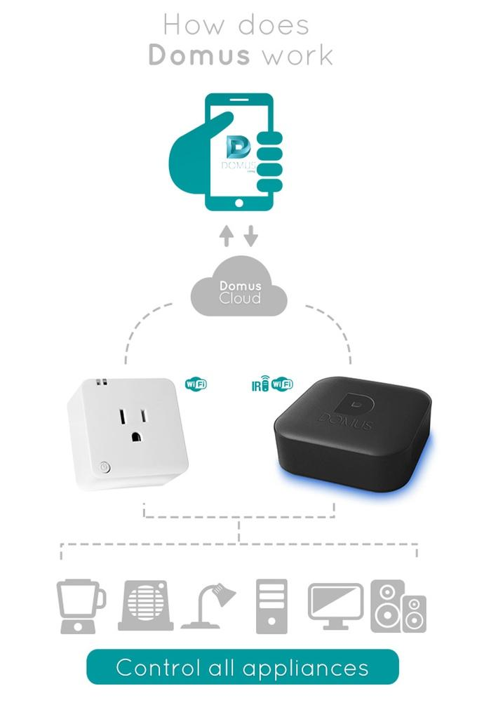

Figure 5

* Picture:

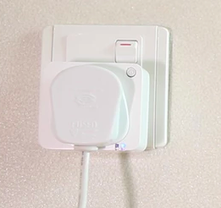 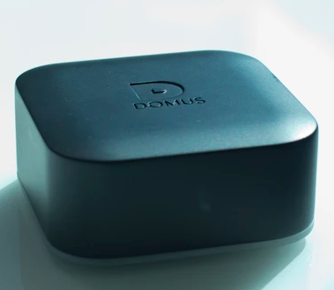

Figure 6 - Smart socket

Figure 7 - Smart iCon

# The Future of Smart Home - B.One

1. Project Summary

The Future of Smart Homes - B.One is a developing project founded by Chairma: Ajun Valluri, Chief Executive Officer: Sridhar Ponugupate, Directors: Sarada Akkineni and Dr. Dave Irvine-Halliday [3]. B.One is a smart home system that allows you to control the security, ambiance, and entertainment from a single app, using only one hub. B.One offers different feature like Qi wireless charger, media manager, universal remote control, automation gateway and irrigation. The strongest application of the B.One is the security system for the house; the security system can be combine with window sensors, motion sensors, camera with night vision, and camera doorbell among other things. B.One is also a learning system that updates with the everyday usage, it get use to your schedule and behaviors, this way the system can alert you if there is something out of the ordinary, like a light on or a machine that can create a hazard. Least but not less important, B.one is compatible with most of the standard sensors and controls in the market, also it will support android, iOs and Windows.

1. Fund Raising Strategy

B.One’s fundraising goal is of $100,000.00 USD and they have already surpassed it and raised $109,893.00 USD from 535 different backers. B.One uses different types of strategies to raise fund for their project. They use rewards as strategy to obtain funds for their project. They have a webinar on IoT where the users can learn how the B.One will change their homes and influence their lives for only $3.00 USD. In addition, those who support them with $5.00 USD or more, their name will be place on the supporter’s page of the project’s website. For $25.00 USD they will send an exclusive T-shirt with the different updates of the journey of the B.One’s project, besides adding their name to their supporter’s page on the website. Also, like the Domus project previously mentioned, the B.One team offer pre-order packages with prices like $79.00 USD for a product that will have a retail price of $149.00 USD, the people who supports them with those package will not only receive the first products that get produced, but their names will also be added to the supporters page of the teams website. There is another package that is being offer for $109.00 that will be retail at $189.00 USD, those who supports this team with this package will receive one (1) B.One Lite Smart HUB, one (1) B.One Door/Window Sensor, and one (1) B.One Motion Sensor, besides adding their name to the supporter’s page of the website. Another package offer by the team to raise funds is a $179.00 USD package in which the backers will receive a full set of B.One system and their name as all the other packages offer will be display on the supporters’ page of their website. For a pledge of $209.00 USD the backers will get 1 B.One Smart HUB, 1 B.One Door/Window sensor, 1 B.One Motion Sensor and their name will be added to their website. There is another package that costs $349.00 USD, for this amount of money the backers will get 1 B.One Smart HUB, 1 B.One Door/Window sensor, 1 B.One motion Sensor, 1 B.One 1080p Wi-Fi Camera with night vision and local storage of 32 GB, and 1 B.One Wireless Siren, besides displaying the backer’s name on the website. A Premium Home Kit Platinum is yet another package that is offer, this package costs $449.00 USD, this cost include a 1 B.One Smart HUB, 1 B.One Door / Window Sensor, 1 B.One 1080p Wi-Fi Camera with night vision and local storage of 32 GB, 1 B.One Wireless Camera Door bell, 1 B.One wireless Siren, and as a thank you to the backers their name will be included on the website. This team, also offers a package for corporate companies, distributors, and resellers which allows them to raise even more funds with a price of $1,700.00 USD per package that includes 10 B.One Smart HUB and 10 B.One Dorr / Window Sensor, besides adding their names to the website. But, the bigger package they offer is a Premium Kit for corporate and distributors which has a cost of $4,290.00 USD that includes 10 B.One Smart HUB, 10 B.One Door / Window Sensor, 10 B.One Motion Sensor, 10 B.One 1080p Wi-Fi Camera with night vision and local storage of 32GB, 10 B.One wireless Camera Door bell and 10 B.One wireless Siren.

1. Technology Overview

The B.One use a parallel computer loT engine that allows ten processors to work in parallel to ensure that every communication in and with the system will be in real time. The whole package include the B.one Smart Hub, a 1080p Camera, Wireless door bell, door sensors, motion sensors and a wires siren.

* Main characteristics of the components

|  |
| --- |
| **Smart HUB** |
| Built-in Radio modules |
| Radios: GSM/GPRS, Wi-Fi, BLE, Zigbee, NFC, Z-wave, 433 Mhz RF for security, IR Receiver and IR blasters |
| Built-in GSM/GPRS module in case of power outage or absence of internet connection. |
| Military standard 256-bit AES encryption with advance built-in firewalls. |
| Future ready framework, it is ready and compatible to work with Insteon, C-Bus, Profibus, Dali, Lonworks, KNX and such others via Zigbee gateway. |
| Power of 10 high in Parallel processors from Texas Instruments and Atmel that makes it the fastest hub available in the market. |
| Qi wireless charger of 5Watt to enable charging of most Qi Compatible phones. |
| Inbuilt SD card memory disk of 32 GB for local storage. |
| On board Temperature and light intensity sensors to automate HVAC control and also to harvest the light by control of blinds / shades based on environment and personal preferences. |
| NFC based sensor for a Tab or pair to the B.One Hub. |
| Wi-Fi to IR convertor for universal remote control |
| Battery backup of 48 hours for security. |
| Media manager function built-in for audio stream services. |
| Proprietary self-learning algorithms, sends notifications, predict / recommend user actions. The more is use the smarter it gets. |

Table 26

|  |
| --- |
| **1080p Camera** |
| Local storage for recording up to 2 weeks of video. |
| Camera view angle: 110 degrees |
| Built-in speaker and High fidelity microphone |
| Supports DNS, FTP, UPNP, DONS, HTTP, SMTP, DHCP & TCP.IP |
| IR night vision |
| Digital motion sensing and alarm notification |
| Complete remote operations, controlled through the smart HUB |

Table 27

|  |
| --- |
| **Wireless Doorbell** |
| Wireless video doorbell with IP 65 protection for outdoor use |
| 720p video resolution for clear view |
| Phone app and regular chime |
| Works simultaneously for 5 users at a time with inbuilt access control. On demand access to keep a check on your surroundings. |
| Do not disturb mode |
| works with the current doorbell connections |
| Remotely unlocks your doors. |

Table 28

|  |
| --- |
| **Door Sensor** |
| Wireless radio: Z-Wave |
| Battery: 3.2 Volt Lithium cell |
| Idle Current: ⩽ 30uA |
| Trigger Current: ⩽ 20mA |
| Wireless transmission range: ⩽ 100m in open area |
| Operation Condition: -15°C~55°C |
| Relative humidity: ⩽ 85% |
| Battery life: 2 years |

Table 29

|  |
| --- |
| **Motion Sensor** |
| Wireless Radio: Z-Wave |
| Battery: 3.2 Volt Lithium cell |
| Idle Current: ⩽ 50uA, Trigger Current: ⩽ 9.5mA |
| Detection range: 8m |
| Wireless Transmission Range: ⩽ 100m in open area |
| Operation Condition: -15°C~55°C |
| Battery life: 2 years |

Table 30

|  |
| --- |
| **Wireless Siren** |
| Wireless Radio: Z-Wave |
| Power Supply: AC 110V ~ 220V, Power Frequency: 50 ~ 60 Hz |
| Alarm Volume: 90 dB |
| Backup Battery: 3.7 V 600mAh rechargeable |
| Alarm current: ⩽ 100mA, Static current: ⩽ 13mA |
| Wireless Transmission Range: ⩽ 100m in open area |
| Relative humidity: ⩽ 85%, Operation Condition: -15°C~55°C |
| Battery life: for at least 30 minutes of siren operation under power cut situation. |

Table 31

1. System Description

The B.one system combine wirelessly a Smart hub with different devices and sensors in your house in order to create a secure and enjoyable environment. The doors and windows sensor, for example, alert the main unit if any anomaly occur and you can see it or control it through your phone app. The same way work with your house security cameras or your wireless doorbell. Also the B.one hub use a “Tap-to Pair” function that allows you to pair and manage any media device so you can create a smart intelligent wireless entertainment center. All these features controlled in the palm of your hand by an easy to use phone app.

* Picture:

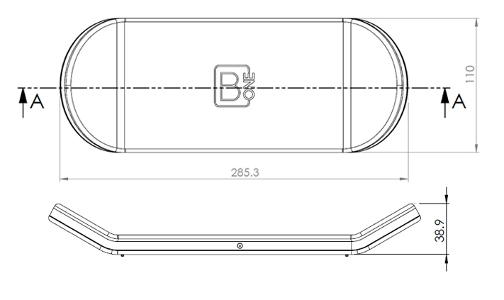

Figure 8 - B.One Smart Hub

* Block Diagram:

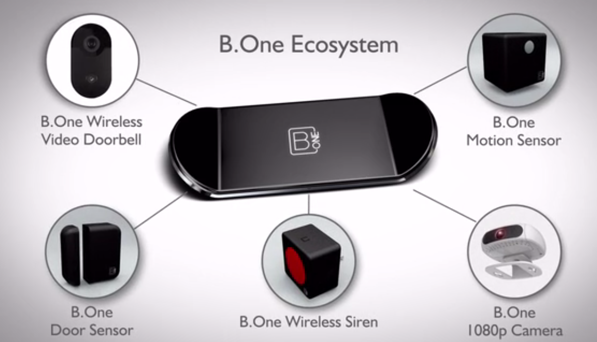

Figure 9

**Conclusion**

If we were to make a fundraising, a good idea will be to promote our project on social media. Also, to affiliate or register to a website like Kickstarter where you can show your progress and persuade the users to help you make your project a reality, by giving you funds. Another way to get funds for our project is to find investors that are willing to support our project.

1. RISK ANALYSIS

On this section we will be analyzing the risks we could have with this project in the different categories shown below and how minimize those risks.

1. *Types of Feasibility*
2. **Technical**
3. How much Technical Risk is there?

Our project can face some technical risk, one of them could be that the microphones in the house do not capture a voice command. Another technical issue will be that some light circuits in the house could exceed our maximum load capability.

1. **Resource**
2. How much Resource Risk is there?

One resource risk could be that a component fails in our design and we could not find a replacement. Our Project has a low resource risk. Since the parts that we use for our design are easy to find. We can work in different areas of our design without affecting the others, and then assemble the unit as one. Also we can simulate different scenarios before connect a real load to the system.

1. **Economic**
2. How much Economic Risk is there?

An economic risk that we could face is that we surpass our budget making the system more expensive that what we have planned.

1. **Schedule**
2. How much Schedule Risk is there?

A schedule risk could be that one components of our design fail and the replacement take more time than usual to arrive.

1. **Cultural**
2. How much Cultural Risk is there?

Sometimes older people present problems to adapt their lives to new technology. Time needs to pass for them to get used to it.

1. **Legal**
2. How much Legal Risk is there?

The project have a low legal risk, the fourth amendment could question our project. However, it is our Policy to respect the privacy of the individuals that use our product. Also, we will not collect information or share any, completely respecting people’s privacy in their homes.

1. **Marketing**
2. How much Marketing Risk is there?

A marketability risk could be that the end-user do not know how the system could be installed or where could be installed in the house.

1. *Risk Assessment*

**Fault Tree Analysis**

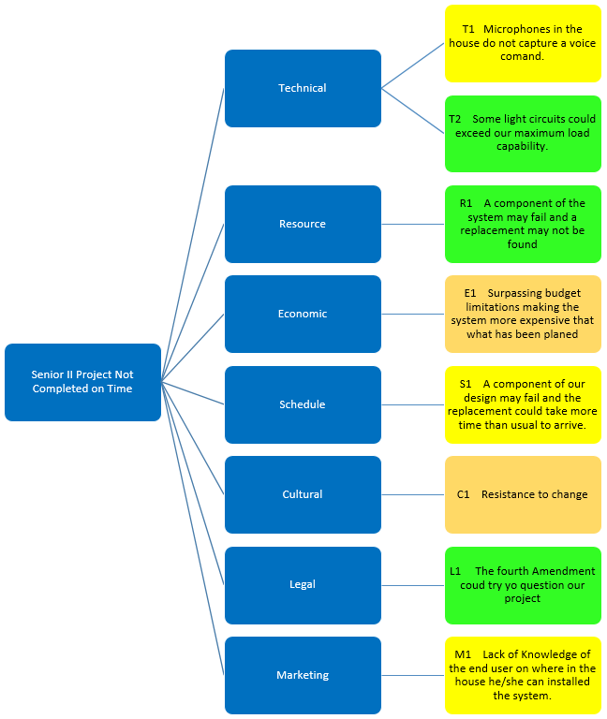

Figure 10

1. *Exposure Matrix*

|  |  |  |  |  |  |
| --- | --- | --- | --- | --- | --- |
|  | | Likelihood of Occurrence | | | Legend |
| Very Likely | Possible | Unlikely |
| Undesirable Outcomes | Class IV |  |  |  | Catastrophic |
| Class III |  | E1, C1 | S1 | Severe |
| Class II |  | T1, M1 |  | Moderate |
| Class I |  |  | T2, R1, L1 | Low |

Table 32 - Exposure Matrix

|  |  |
| --- | --- |
| **Actions** | |
| T2, R1, L1 | None |
| T1, S1, M1 | Test system before selling it |
| E1, C1 | Support line needs to be created to help the end-user with any problems |
|  | System should be change |

Table 33

**Conclusion**

Every project in its developing stage has its risks, and ours is not the exception. However we did not find any critical risk that could affect our project making it impossible to build; but we do believe that we need to have a continuous risk management. The first step of the risk management is to identify the specific risks our project has. The list we produced includes risks in every aspect of our project such as the Technical risks, the Resource Risks, the Economic Risks, the Schedule Risks, the Cultural Risks, the Legal Risks, and the Marketing risks. Each of this risks has a different level of acceptance, none of our risks made it to a level IV meaning that none of the risks exceeded the risk acceptance threshold making it safe to start work in the project. Some of our risks do have a severe level of risk which is level III, this level of risk requires constant management, and we believe that creating support lines to help the end users with their problems and questions will mitigate the risks. Those risks that are in this category are the economic risk that is something we as the developers need to manage to be able to remain within the budget. Also the cultural risk is a level III risk that could affect our sales if some of the intended end users refuses to make changes in their lives, especially accepting new technology like the system we are creating; this we can mitigate, making demonstrations on how easy will be to use the system and showing the intended users how much better their lives will be with our system especially the elderly and people with physical impediments that will be able to take advantage of the voice command aspect of our system, giving them some independence. Lastly, the schedule risk is also in the level III risk table, it is severe since it will be out of our hands if a component takes longer than usual to arrive in case of a replacement needed. In order to mitigate this risk is to always have backup modules in case one fails, just in case, even if they never do. Among our risks we also have level II risks that are risks that are accepted within the threshold and no constant management is needed. This moderate risks in our project holds a technical risks which is that the microphones in the house may not capture a voice command, in order to mitigate this risk we need test the systems before putting them out in the market, to make sure every single component is working properly at high ranges. The other risk that lies in a level II is the marketing risk, this risk consists on the end user not knowing where in the house to install the system. However, it is our job to market the system well enough to answer all of the questions the end user may have and give the ideas they need to make sure they know where they can place and install the system to enjoy it at its maximum performance. The rest of our risks fell on category level I, which do not require any active management. In this category we have a technical risk which is that the light circuits of the house could exceed our maximum load, which is very unlikely because our system will be equipped with a Triac board that can handle 16 Amps, while a house only requires 15 Amps breakers. Also the resource risk is part of this category, since it is very unlikely that if a module of our system fails not to find a replacement part, since all these units and modules are very easy to find in the market. Lastly, the legal risk, which is not something that we need to worry about, since we are not going to infringe the fourth amendment, it is one of our policies to respect the privacy of the individuals that uses the product, also, we will not collect any information or share any, completely respecting people’s privacies in their homes.

1. OPERATING ENVIRONMENT

Design a device that can withstand the daily environmental hazards may be the key of success in a project, so is very important to analyze our system operating environment. Our system will be mainly installed inside the house in a closet or attic. In a worst case scenario the users will install the unit outside the house and the system is going to be expose to heavy rains, sun and dust. Since the system will be installed and attached to the infrastructure of the house, the unit should not suffer high drops. Another condition to take into consideration is the temperature of operation. The system will be most likely installed in attics what makes the temperature around 90° F. Finally, in these locations the system may be exposed to small animals or insects, so the system need to be in a box.

1. INTENDED USER(S) AND INTENDED USE(S)
2. *Intended User(s)*

Nowadays, people loves technology and demand good products. Smartphone and tablet dominate the market and almost everything is controlled by phone applications. That is why we will include a smartphone app where the user can interact with the system. Also, people like to be in touch and available everywhere, so our system needs to be capable of making calls to the user’s contacts. In addition, older people that are not familiar with new technology and smartphones need to be able to use our system, so we are going to integrate a voice command feature that will make their lives easier.

1. *Intended Use(s)*

In our system the voice command will be one of the features with more use, so the voice command module need to be equipped with long range Mics to ensure a better quality. Also, since the system will monitor the doors and windows, the unit will need magnetic contact switches. In addition, a phone application is need to have control over the system which will be manage though a Wi-Fi module. Light control will be another feature with a lot of use. For these attribute we are going to use a Triac board with at least four entries that allows the system to control different area lights. The system will also manage the garage door through a relay and the user will also be able to make phone calls using a phone module. Finally, in order to integrate the system to the house, the unit will be enclosed in an electric box that protect and ensure a safe connection.

1. BACKGROUND

Upon searching of competing products that are already in the market. Listed below are three products with their respective manufacturers and synopsis, giving a simple glimpse of what the current state of the art on smart home automation control systems.

1. *VOCCA*
2. Project Summary

The VOCCA is an available technology developed by a team from Tel Aviv, Israel integrated by: Erez Nimrod, Ori Indursky, Vladislav Serebnik, Adi Malik, Ofer Masamy, Maggi Yovov, and Nir Dvash [4]. VOCCA is a smart lighting system which does not required Wi-Fi, professional setup, or installation since it is a simple plug and play voice activated bulb adapter. The way VOCCA is set up is very simple; any light bulb can be simple screw into the adapter and then connect it into the light socket. There are two versions of the product, one is the standard model which, after the VOCCA is installed, turns off or on the lights when the user said “the magic words” “Go VOCCA Light.” This is already for sale and the prices start at $39.70 per unit, but there are discounts available if the customer purchases more than one. The other version of the product is the customizable advanced model, named VOCCA Pro. This type uses Bluetooth connectivity with an app which can be obtained free of charges, it can be downloaded either for iPhone or Android. The differences with the standard version are that this one allows the users to record their own voice trigger and they can be up to 5 different triggers simultaneously, in that way they can use any language, and they can have different people using different triggers; it also allows set a specific time for the lights to turn on or off. This advanced version is not in the market yet but according with the official website it will be available for purchase soon.

1. Technology Overview

VOCCA system at a simple look seems to be a regular socket or light bulb adapter, but inside it has all the technology to turn a common bulb into a smart bulb. It has a small microphone inside connected to the voice recognition device from Sensory Inc., this part of the system is searching 24/7 for the trigger phrase to commands the relay to transfer the power from the mains to the light bulb. The power is handle by a common AC to DC converter, and in the case of the VOCCA Pro a Bluetooth system is used for communication with the Smartphone app.

* Main characteristics

|  |
| --- |
| **VOCCA** |
| Item Weight: 0.3 ounces |
| Product Dimensions: 4.4 x 3.4 x 2.7 in |
| Power Source: AC (It works on both 120/240 AC systems) |
| Wattage: consumes less than 0.25W |
| Voice recognition technology: from Sensory Inc. (the world's leading voice recognition technology company) |
| Bluetooth Specifications: TobyRich Bluetooth Smart and Bluetooth Low Energy (BLE) app design. |

Table 34

1. System Description

The VOCCA developed team had as their number one purpose to make life easier and simpler, reason for what they created this voice activated, easy-to-use device. Because it requires no Wi-Fi, no hub and no configuration, anyone can install VOCCA. The regular light switch still works when VOCCA is connected so habits don't need to change. It is a product for life as users don't need to buy a new one when the bulb dies. VOCCA is based on voice recognition technology from Sensory Inc. and it is on 24/7 in search of the trigger phrase. Once found, it commands its relay to transfer the power from the mains to the light bulb and there is light (or darkness). VOCCA Pro uses TobyRich Bluetooth Smart and Bluetooth Low Energy (BLE) app design. The VOCCA app has a very simple interface which is very convenient in order to be used by anyone. It allows customizing VOCCA Pro, with a built in fail-safe system and creates the user's own triggers. This app also allows setting VOCCA to automatically switch on when users want to wake up, or turn off at bedtime, and manually controls all VOCCA’s devices in the house from the Smartphone. In order for VOCCA to works the light switch have to be in the on position. The distance required between the device and the person who said the trigger depends on how much background noise is present in the room. The optimal distance is between 10 to 15ft, but with low level of noise the distance could be extended up to approximately to 30 ft.

1. Block Diagram:

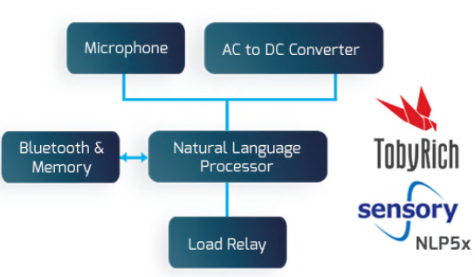

Figure 11

1. Picture:

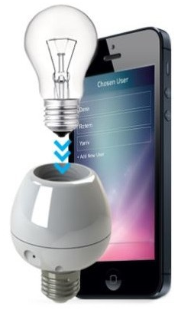

Figure 12

1. *Homey*
2. Project Summary

Homey is a voice-controlled home automation technology that allows you to talk to your room. It was developed by a large team from Enschede, Netherlands of over 15 members (Athom) [5]. Homey is described as a personal assistant that will help make a home more personal, since it is designed to control “from lights to music, from climate to TV.” The possibilities of this device are many, especially combining functions; for example, it is able to sync the light and the coffee machine with the alarm clock, making the user’s morning an incredible experience, it made seem like the house is alive. It can be controlled by voice commands when the user is inside the house or by an app (available for either an iPhone or an Android phone) to easily control your whole house when the user is outside the house. Homey is multilingual; it currently understand and speaks 5 languages (English, Spanish, French, German, and Dutch), by the developer team is working to expand the availability to more languages. Because the voice commands are the easy way to give Homey orders, anyone (since kids to elderly) can use it; the trigger is its name of the device “Homey”, but the name can be change to anything. Homey will need Internet connection in order to work properly since the voice recognition just works with online access, and with the app access it will only works if the Smartphone is in the same Wi-Fi; therefore, it will still work offline but with a lot of limitations. It can be obtained at the official website for €299, and no shipping cost, to anywhere in the world. Homey had reached several achievements, among them, it was a semifinalist in the PHILIPS Innovation Award and it was in the top 5 in the Accenture Innovation Award as well.

1. Technology Overview

Homey is a complex system that has in total 8 radio modules, which are accessible through a high-level JavaScript API:

• Wi-Fi 802.11b/g/n

• Bluetooth 4.0

• NFC

• ZigBee

• Z-Wave

• 433.92 MHz

• nrf24l01+

• Infrared

These are all connected to a Raspberry Pi Compute Module, which runs the custom software, but for the consumer product this will be replaced by its industrial variant, the compute module. Homey runs on a node.js server, so developers can make use of the easy-to-learn JavaScript language. Homey works with a 12V adapter and an adapter to plug. The sphere is 11 cm (4.3") in diameter. In the middle you will find a multi-colored LED ring that empowers apps to give feedback to the user, and the small circle on top is for the Infrared Power-LED to shine through the casing. The Homey Smartphone App is available for iPhone and Android users. Users of other operating systems can use their browser to access and configure Homey on the go.

1. System Description

Homey start working when its name is called and, in dependence of the command, it can communicate with the user giving her/his feedback or it can communicate with the appliance to obey the command. As of now it is able to communicate with devices through 8 different radio technologies:

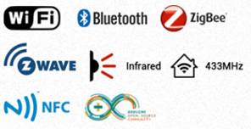

Figure 13

Since the user plugs it in, Homey starts working with most of the devices of the house that have one of the previous radio technologies. It not just only connects with the house appliances, but also with the user’s entertainment systems and online accounts. Homey already works with:

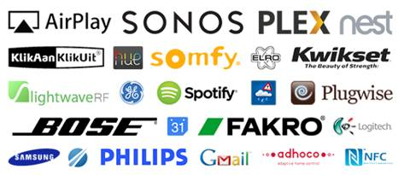

Figure 14

The system includes 8 wireless modules that work on various frequencies and protocols, all integrated together in an intelligent and easy-to-use device with state-of-the-art speech recognition that activates Homey when it identifies the trigger command by a microphone.

Homey is made in an open platform, works with apps written in JavaScript, so everyone can develop for it and contribute. Initially the speech recognition used was a hybrid between Microsoft's and Google's, combined with a display for visual feedback. But finally Node.js is used with Google's speech recognition.

Homey uses a powerful and energy efficient ARM chipset (same technology that Smartphone) which means that it does not use much energy; therefore it will not increase the electricity bill of the house.

Homey does not stores any conversation, since it will be active only after its name is called, the commands are saved in the command history but can be deleted at all time.

Homey presents limitations; most of the appliance of the house can be controlled with one Homey, mainly if they are connected through Wi-Fi, but if the appliance is controlled by for infrared light, it will need be in the same room of the Homey. Also, since the Homey has the microphone inside, the user needs to be in the same room in order to give a voice command; if the user is in a different room, he/she can still give Homey commands through the app, but for the appliance that are not in range the solution will be hook multiple Homeys in the house (which will raise the price of the technology), and they will work together.

1. Block Diagram:

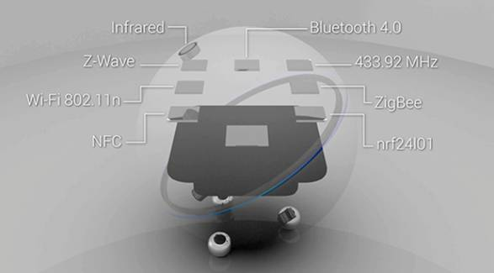

Figure 15

1. Picture:

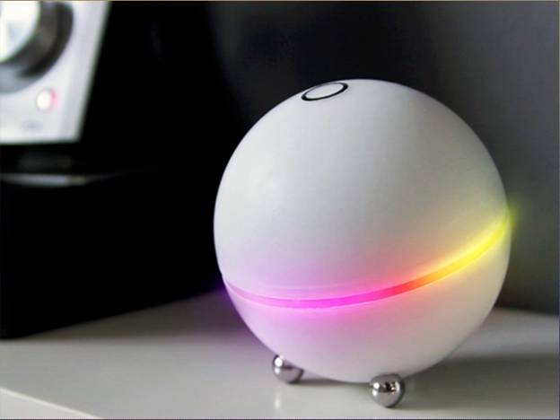

Figure 16

1. *NEEO*
2. Project Summary

NEEO, the Thinking Remote is a revolutionary remote that allows home automation by hand recognition. It was co-founded by Raphael Oberholzer (CEO) and Oliver Studer (CTO) of NEEO Inc [6]. NEEO is a smart home automation system that connects and controls the devices of the house in very simple way. Instead of having a control remote for every device, this technology enables the user to have only one control for all of them. It is compatible with all major products from the last 10 years to the newest in the market. NEEO does not require technical installation; once it is set up, it gets all the devices with just one button press. NEEO is also very easy to use; therefore it can be used for everyone in the house. This system is integrated by two main parts, the Remote and the Brain. The NEEO Remote is the interface to control the AV (Audio/Video) devices and smart home gadgets; it allows the user to access everything instantly in one single place. And if the user loses the remote in the house, it can be easily find by NEEOs SOS feature. The other part of the system, the Brain, is the one which commands the smart devices and gadgets. The NEEO Combo (Remote and Brain) can be obtained for $319; the price for the Brain itself is $219; and the price for just the Remote is $119. NEEO has won two design awards in 2015: “iF Design Award 2015” and the “reddot award 2015.”

1. Technology Overview

NEEO is integrated by 2 main parts, the Remote and the Brain. The Remote is made by a very solid long lasting anodized aluminum which protects against damage and resists fingerprints. It has a 291 ppi display (more than Apple’s iPad Retina standard). It is simple, just a few buttons and a touch screen for browsing and control. The Remote is also very personal since it works with hand recognition technology for personal profiles and this allows parental control and guest profile for unrecognized hands. The body of the Brain is made of aluminum for a lightweight rigid structure, and the top and the bottom are made of a specially manufactured acrylic glass. It can receive the information in order to command the device from the NEEO Remote or the app for the Smartphone. It is wireless, it utilizes the major protocols as Wifi, Bluetooth, ZigBee and Z-Wave among others. The Brain also has a 360º infrared blaster design. The system is complemented by the NEEO App which commands the brain and all the devices from one single app. It is available for iOS® and Android® phones.

* Main characteristics

**The Remote**

|  |
| --- |
| **Size & Weight** |
| Height: 7.1 inches (182mm) |
| Width: 1.9 inches (48mm) |
| Depth: 0.36 inch (9.2mm) |
| Weight: 0.17 pound (80g) |

Table 35

|  |
| --- |
| **System** |
| ARM® Cortex® M4 single-core at 168MHz |
| Running extremely efficient NEEO OS |
| Intelligent power management |
| 32MB RAM |

Table 36

|  |
| --- |
| **System Requirements** |
| 10/100BASE-T Ethernet network for initial setup |
| Wi-Fi (802.11 b, g, or n) wireless network (to operate device wirelessly) |
| Min. iOS 8 or Android 4+ for the NEEO App |
| 1 or more NEEO Brains |
| NEEO Account (free) |

Table 37

|  |
| --- |
| **Display** |
| Ultra-thin bezel display |
| 3 inches (diagonal) LED-backlit widescreen multi-touch display with IPS technology |
| 480-by-800-pixel resolution at very high density of 291 ppi |
| Fingerprint-resistant coating |
| Fully laminated display |
| Unique NEEO multilayer design for thin bezels |

Table 38

|  |
| --- |
| **Ports & Interfaces** |
| Wi-Fi (802.11b/g/n) |
| IEEE 802.15.4 dual antenna (6LowPAN and ready for Thread, ZigBee) |
| Accelerometer |
| NEEO Palm Sensor (BETA) |
| Capacitive sensors |
| Charging connector (gold plated) |

Table 39

|  |
| --- |
| **Compatibility** |
| TV, Sonos®, Apple® TV, Roku®, and Philips® Hue support |
| Supports cable boxes - including Cablevision®, Verizon®, Time Warner®, and Comcast® |
| Supports satellite systems from Dish® and DirectTV® |
| over 30,000 supported devices |

Table 40

|  |
| --- |
| **Power** |
| 1200mAH Li-Ion battery (replaceable) |
| External 10W charger (included) |
| Charging via NEEO Docking Station (included) |

Table 41

|  |
| --- |
| **Environmental requirements** |
| Operating temperature: 32° to 95° F (0° to 35° C) |
| Storage temperature: -4° to 113° F (-20° to 45° C) |
| Avoid direct sunlight |

Table 42

**The Brain**

|  |
| --- |
| **Size & Weight** |
| Height: 0.9 inch (24mm) |
| Diameter: 4.1 inches (106mm) |
| Weight: 0.2 pound (95g) |

Table 43

|  |
| --- |
| **System** |
| 1,2Ghz dual-core ARM A7 |
| 4GB flash storage |
| 1GB RAM |
| Fan-less, low power design |

Table 44

|  |
| --- |
| **System Requirements** |
| 10/100BASE-T Ethernet network for initial setup |
| Wi-Fi (802.11 b, g, or n) wireless network (to operate device wirelessly) |
| Min. iOS 8 or Android 4 for the NEEO app |
| NEEO account (Free) |

Table 45

|  |
| --- |
| **Ports & Interfaces** |
| Wi-Fi (802.11b/g/n) |
| Bluetooth 4.0 |
| Z-Wave Plus (500 series / US, EU Version) |
| IEEE 802.15.4 dual antenna (6LowPAN and ready for Thread, ZigBee) |
| 10/100BASE-T Ethernet |
| Built-in IR receiver (learning mode) |
| Unique internal 360° IR blaster design (just works) |
| 3.5mm jack IR output (for included 360° extender, allows operation of devices inside and outside cabinets) |
| HDMI CEC (for future use) |
| Capacitive button |

Table 46

|  |
| --- |
| **Compatibility** |
| TV, Sonos®, Apple® TV, Roku®, and Philips® Hue support |
| Supports cable boxes - including Cablevision®, Verizon®, Time Warner®, and Comcast® |
| Supports satellite systems from Dish® and DirectTV® |
| over 30’000 supported devices |

Table 47

|  |
| --- |
| **Power** |
| External 10W power supply (included) |

Table 48

|  |
| --- |
| **Environmental requirements** |
| Operating temperature: 32° to 95° F (0° to 35° C) |
| Storage temperature: -4° to 113° F (-20° to 45° C) |
| Avoid direct sunlight (might reduce infrared emitter performance) |

Table 49

1. System Description

The setup is very easy, the Remote allows the user to add devices by just typing the name, and then NEEO automatically find it and the user can assign a room to it; this can be also done by the NEEO app. When the user grabs the sensors in the Remote recognizes the hand and automatically match it with the user’s profile and display the playlists, films, and favorites. Then the user just needs to search the devices which already have an assigned room and command an order. Then the Brain receives the command and communicates with the house devices via wireless systems as Wi-Fi for example and via its 360° IR design; in that way it can be place in any room of the house for the user convenience. The system has over 30,000 supported devices and related to thermostats, it supports Nest 1st generation and Nest Thermostat 2nd generation. The Remote has a range of approximately 50 m (160 ft.), but it also depends on site specifications and individual device capabilities; and it the battery lasts for more than a month without re-charge. NEEO is not just for a house, it can be also uses for offices.

1. Block Diagram:

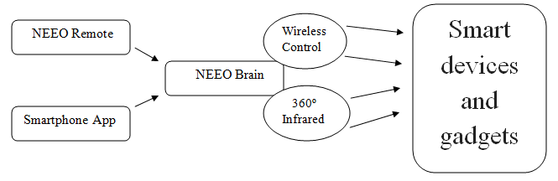

Figure 17

1. Picture:

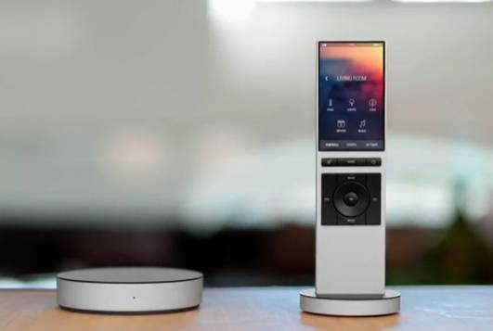

Figure 18

1. INTELLECTUAL PROPERTY

The following three patents are relevant and appear on the United States Patent & Trademark Organization when ‘*home automation*’ is searched on the site’s engine. The first patent, Automation Control of Electric Devices, comes from Utah by W. E. Smith and J. R. Gist; followed by Voice Control Device and Voice Control Method by Guo-Feng Zhang of Shanghai China and finally, Actuator for Electric Blinds invented by Masanori Kobayashi, Niigata, Japan.

1. *Automation Control of Electronic Devices, US 9,152,139 B2* [7]
2. Summary

“A sensor lighting control system automatically controls lighting on a ***home automation*** network without creating unnecessary network traffic. A sensor module uses the light level to determine when a command to turn the light ON should be resent over the network” [7].   
 This patent claims a complete home remote control automation system of varying electronic devices from DVD players to lights and etc… Although our system was to be able control some different aspects of the home there are similarities in the way the devices interface with each other. There are the exact means of communications intended to be use in this proposed project.

An automation controller will be able to access the electronic devices for a remote control system via a network. Allowing for Analog and Digital video/audio signals to be transmitted with a coupled automation controller.

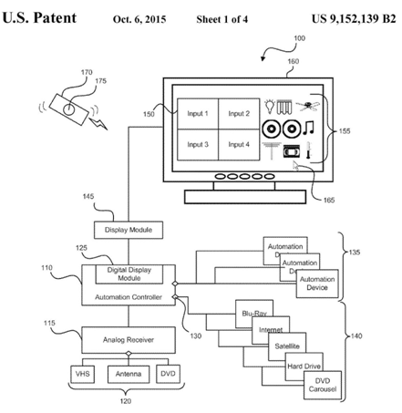

Figure 19

1. Claims Summaries

“An automation control system for control of electronic devices, comprising: an automation controller comprising a communications port configured to provide control signals to control electronic devices via a network, wherein the electronic devices comprise lights and a video device…”[7] Having a separate automation controller and an analog receiver to have a control interface from the automation controller. Allowing control options for the lights i.e. dimming and turning on and off lights.

1. Non-Infringement

At first glance, the patent seems to broad so ‘Morse v. O’Reilly’ can be used since the idea of having a patent controlling analog and/or digital devices through an RC or WIFI, does that mean that controlling laptops through SSH on a Wi-Fi home network violate this patent? If it’s just limited to the electronic devices listed, like VHS, DVD, etc. Then we shall focus on implementing other day to day electronic devices in our patent or consider licensing until we can show the patent is too broad and recover any lost profits.

1. *Voice Control Device and Voice Control Method US 9,153,232 B2* [8]
2. Summary

With a device that receives voice commands, “The voice control device includes a sound receiver, a sound converter, a voice identifier, and a central processing unit (CPU).”[8] Receiver picks up the sound in analog and passes to the converter which converts to digital. The identifier compares the signal with a reference signal and sends to verify. Once verified it sends a wake up signal. After receiving the wake up signal the CPU leaves it is idle state, makes another comparison and takes the input.

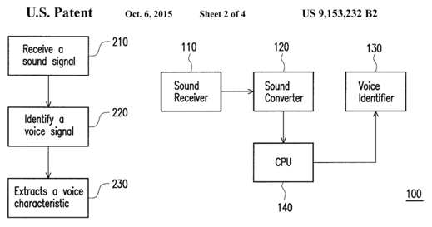

Figure 20

1. Claims Summaries

“A voice control device, comprising: a sound receiver, receiving a first sound signal; a sound converter, coupled to the sound receiver, and converting the first sound signal from analog signal to digital signal; a voice identifier, coupled to the sound converter…” [8] Identifier identifies the first voice signal from the first sound signal it receives and performs a comparison of the signal with a reference voice signal, sending a wake-up signal in response to the matching of the signals. A CPU coupled to the system, where the CPU receives the wake-up signal and begins working. CPU also performs a second comparison, the CPU takes the voice input from the sound receiver and the sound converter.

1. Non-Infringement

The voice identifier that is a specific embodiment in the patent will not be used in the Project, allowing anyone on the network to access the system or just limit voice to only through smart phone interfaces, i.e. Siri.

1. *Actuator for Electric Blinds, US 4,773,464 [9]*
2. Summary

“Herein disclosed is an actuator for actuating a vertical blind or curtain of electric type to be mounted on a mounting support face.”[9] To stop deformities like torsions of rods and ensure their rotations by driving it with the torques of a pair of motors. The tension can be adjusted to the rod by fastening the threaded rod connected to the traverse rod. Rotation unit is held in a pivotal position.

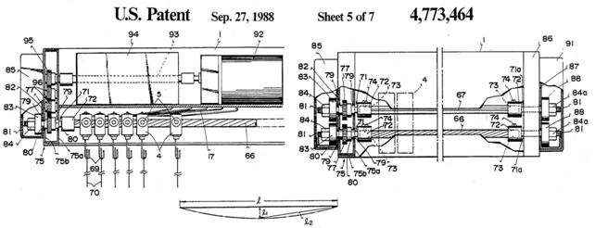

Figure 21

1. Claims Summaries

“ In an electric blind to be mounted on a mounting support face, comprising: a generally elongated casing frame having a pair of longitudinally extending guide rails”[9] Having a long rod translates to rotatable in the frame; the runners which rotate and run one after another on the rails when the system drives them.

1. Non-Infringement

For the blind system, there will be an improvement to allow for mechanical hand use along with electric motor and allowed to be controlled by an automation controller through a network.

The Alfred trademark, is dead, abandoned on October 6, 2015.  
 Serial Number 86599812 [10]

1. STANDARDS CONSIDERATIONS

These following standards published by the IEEE will be our guides when developing our system. From how to interface the different devices in the system, to protecting them from the various hazardous conditions of the world, to the methodology of the development.

1. IEEE Std 1905.1a-2014 - IEEE standard for a convergent digital home network for heterogeneous technologies
2. This standard applies a level of abstraction so that multiple technologies have a common interface to network on.
3. We will be incorporating IEEE 1905.1a-2014 when we use the TAP interface (simulates layer 2 data link), which is one of the virtual networks in Linux. With no need for IP addresses, just shuttling packets back and forth, our system can take advantage of multiple different devices with different protocols.
4. IEEE Std. 1872-2015 - IEEE Standard Ontologies for Robotics and Automation
5. These Ontologies for Robotics and Automation are developed to be a methodology for knowledge, a unified way. Providing definitions and allowing for transfer of knowledge unambiguously.
6. We will be using this methodology; with all its conventions and definitions for automation for our local coordinate systems.
7. IEEE Std. C62.36-2014 - IEEE Standard Test Methods for Surge Protectors Used in Low-Voltage Data, Communications, and Signaling Circuits
8. This standard was originally developed to establish methods for testing characteristics and for identifying criteria that determine the end of life for surge protectors used in low-voltage data, communications, and signaling circuits. This edition of the standard is a major rewrite of the 2000 edition. It has two main changes from the previous edition. One is reformatted test clauses so that each test clause now has sub clauses covering background, purpose, equipment to be used, protector states to test, a step-by-step test procedure, alternative tests (if any), suggested test data, requirements (if any), and comments (if any). The second is reorganized tests by characteristics and ratings, rather than by non-surge performance tests and active performance tests.
9. We will be incorporating IEEE Std. C62.36-2014 to properly test our implementation of surge protection to avoid possible problems that could ruin the system.

In conclusion, there will most likely be more standards to be incorporated as progress is made; these first few are a glimpse into what other standards might be applicable to our system. We will be including:

* IEEE Std 1905.1a-2014
* IEEE Std. 1872-2015
* IEEE Std. C62.36-2014

1. GLOBALIZATION

We believe that our voice command smart home system will be a successful product and people around the world will love it. This system has been designed not only thinking in bring you an innovative and revolutionary smart solution to your home. It is designed to be a worldwide product that will meet the needs of the market nowadays complying with all the required standards and regulations. Our system will not harm the environment and safety is a priority in all aspects of our design. Also, this voice command smart home system is made having in mind different countries and cultures opinion that helps to guarantee a high quality end product with a positive global acceptance. The result is a product with a competitive affordable price, safe, easy to use, that people simply will love it.

1. *World Trade Organization*

The World Trade Organization comes from the Uruguay Round Negotiations (1986-1994) and it was established on January 1, 1995. The organization comprises 161 countries as of April 2015; it is established in Geneva, Switzerland and had Roberto Azevêdo as Director. [11] “WTO is the only global international organization dealing with the rules of trade between nations. At its heart are the WTO agreements, negotiated and signed by the bulk of the world’s trading nations and ratified in their parliaments. The goal is to help producers of goods and services, exporters, and importers conduct their business, while allowing governments to meet social and environmental objectives.”[12] The main function of the world trade organization is that trade flows as smoothly, predictable and freely as possible. In order to achieve that, the WTO offer forums for trade negotiations, handling trade disputes and monitor national trade policies. Also, they offer technical assistance and training for developing countries, and cooperation with other international organizations. In addition, the WTO ensure that all organizations, companies and government know that the rules are worldwide and give them the confident that there will be no sudden changes of policy. Below are some of the rules or agreements that The World Trade Organization stands for:

1. Non-discrimination.

A country should not discriminate between its trading partners and between its own and foreign products, services or nationals.

1. More open trade.

Encouraging trades by lowering trade barriers like customs duties or tariffs.

1. Predictable and transparent.

Trade barriers should not be raised arbitrarily, a more predictable and transparent trade given the business a clear view to their future opportunities.

1. More competitive.

This rule stands against unfair practices like dumping products at below cost to gain market and how government can respond by applying additional charges.

1. More beneficial for less developed countries.

These countries have more time and flexibility to adjust to the WTO provisions.

1. Protect the environment.

WTO permits members to take measures to protect the environment, public health, animal health and plant health. All in a fair way that include national and foreign business.

To conclude, The World Trade Organization deals with the rules of trade between nations. It’s a forum for governments to negotiate trade agreements. It is a set of rules for international commerce. And, it helps to settle disputes.

1. *Importance of Eliminating the Barriers to Trade*

In this section we will talk about the importance of eliminating barriers to trade, but what are trade barriers? Let us take a look at this particular definition “Trade barriers are measures that governments or public authorities introduce to make imported goods or services less competitive than locally produced goods and services”[13] From this definition we can appreciate that eliminating these barriers could make the difference in our design’s global acceptance. These barriers could have a technical or administrative nature and they are generally classified as; Import policies reflected in tariffs and other import charges, quotas, import licensing, and customs practices. Standards, testing, labeling and various types of certifications. Lack of copyright protection. Restrictions on franchising and restrictions on foreign direct investment.

One of the best ways to elaborate a high quality product that had a global acceptance is to comply with the required regulations and standards. This ensures public safety and drive market development. Also, guarantees that your product can be accepted in a foreign country. For example, these are some of the standards applicable to our system, IEEE Std 1905.1a-2014 -IEEE standard for a convergent digital home network for heterogeneous technologies. IEEE Std. 1872-2015 -IEEE Standard Ontologies for Robotics and Automation, and IEEE Std. C62.36-2014 -IEEE Standard Test Methods for Surge Protectors Used in Low-Voltage Data, Communications, and Signaling Circuits. More standards will be incorporated as progress is made, always looking forward to eliminate barriers to trade.

1. *Collaboration Tools*

Design a successful project involves collaboration, planning and coordination between all the team members. Fail to comply with the project schedule and due dates could end in a delayed product. We live a busy life and sometime is hard to find the right time to meet and share ideas or documents. Our team, in order to avoid those situations, have been used some collaboration tools that help us to keep in touch and focus on our project goals. Google Drive, for example, is a great tool that let you create a folder and share the documents in there with your team members. Later on with Google Docs any of us can work on those documents over the Internet, even all at the same time, so in that way we can be on track and work in the project from home. Although, this is a great set of tools, stay in contact and meet frequently is a necessity for planning and coordinating the project. We use phone applications like ooVoo and GoToMeeting that help us a lot to stay in contact. With these apps we can do video conferences, share files and ideas in real time, like we were in a meeting room. These tools were very useful for us in term of collaboration during our project and helped us to eliminate the lack of communication when we were travelling or in different locations.

1. *Perspective of our product in different countries and cultures*

We believe that our voice command smart home system design will be accepted and will have a good perspective in other countries and cultures. For example, Raynel Díaz Santos, electrical engineer and professor in the faculty of electrical at Instituto Superior Politécnico José Antonio Echeverría (CUJAE) told us that the idea was excellent and innovative for a country like Cuba that right now is on the search of new technologies. He thinks that the product will be accepted and people will love it. On the other hand, insert the product in the construction models available in the island will be a challenge and a gradual process. Raynel explained that the country is experiencing substantial changes in their usual construction style, induced by the influence of new cultures. This should be good for our design he said, since the old houses structures are made of concrete and the electrical system is almost impossible to change or modify. Now with new construction styles the system will be a great idea. Also, Internet is a topic in development in Cuba, but since the system can work without an Internet connection, no monthly fees are present and the system will be a perfect option. Samuel Beltran, a computer engineer from Colombia told us that the idea is good, but he believes that the people who can afford a smart home system do not live in houses but in apartments, therefore the voice command to open the garage door will not be needed. Helbert Quevedo a policeman who works in small towns and have seen smart homes, he helped us to realize that in Colombia there are companies that will go to your house and change all of the electrical systems to make your home smart; it is not like here United States, where we can buy every component and change it ourselves if we want, also they have to pay for a monthly service fee. This monthly fee does not make the system affordable, since the user not only have to pay for the actual system, but also for the set up and add a monthly fees. To sum up, if we take into consideration these different ideas and opinions, we can design a successful product with a great acceptance in different cultures.

In conclusion we believe that if we make our system affordable, molded to the needs of different cultures, easy to use and complying with the corresponding standards and regulations, we can have an end product that will meet the needs of our clients, the needs of the market, with a global acceptance and with the less trade barriers possible.

1. HEALTH AND SAFETY

In this section we are going to explain how our team will follow practices and procedures that will protect not only our health and safety, but the end users as well. Also we will show that we care about liability and make use of foreseeability.

As engineers our main goal is to design a product that does not affect our health or the health of the users in any aspect, that is why safety is a priority in or design. As a team, we avoid wearing metallic object when we are working with electricity. Always try to work together so no one is alone in case of an accident. Also, we try to avoid working with hot circuits and with broken electric components. In term of the design, our product will be enclosed in an electrical box with the proper wiring connections, labels and precautions in order to protect the user from electroshocks. The product follows all the safety design rules that includes using copper wire with their respective size per amps showing in the National Electrical Code table 310.16. Furthermore, the device is well grounded using the correct wire size that match the outlet over-current protection. In addition, conductors with more than 14 volts DC are not exposed in our product. The design will not contribute to increase the amount of electronics waste in the planet, since we avoid the use of batteries and other electronic parts that can damage our environment and our health. In addition, this is a product designed for a long useful-life period. Liability is another aspect that our team is concerned about. We believe that our costumer’s satisfaction is a measure of our success. In order to warranty the success, our product has been designed with different construction layers that make it easy to repair and / or replace, that way the relationship costumer-vendor is more fluent. Finally, our team spends time analyzing every manner in which our product might be used or misused because we understand that it is our responsibility to anticipate the different failures that our product could present when it leaves the factory.

To conclude, we believe that our product has been designed having in mind the safety and health of our costumes. Our team applied foreseeability and take into consideration the different responsibilities with the end user.

1. ENVIROMENTAL CONSIDERATIONS

In this section we will cover the various materials of the parts that we are looking to use in our project. Since our design mostly consist of electronic components, there will be a sharp discretionary focus on said materials to eliminate as much E-waste as possible. The following is an overview of some of available pieces in the market, ready to be shot onto a printed circuit board, and the different materials inside; there will be exceptional consideration to make sure that it is compliant to the Restriction of Hazardous Substances Directive, WEEE directive, and what other standards may apply.

The Atmega 2560

Atmel microcontroller unit, the Atmega 2560, which is featured in many devices including the popular Arduino developer board, is RoHS compliant. It contains no lead, cadmium, or other problematic materials.

60/40 Rosin-Core Solder

Although it has solder with a leaded rosin flux core, it allows for easier disassembly. It has been used in demonstration builds but special consideration is being considered to use a lead free alternative even though it is of lower quality.

A small LCD screen

The system is to work upon commands via voice instruction or cellular phone but there might be benefits to the user if a small screen was made available to display important information to the user on the base system. The liquid crystal display won’t be the burden that televisions are but it still of a toxic substance. It would be ideal to possibly get away with a screen smaller than 4” but special consideration should be taken for those with troublesome vision that would use the product.

With each different component, material, and substance comes the responsibility that we have to planet and all the creatures in which we co-exist with. Our aim is to be as energy efficient as possible with our design and have the customers breathe a sigh of relief when realizing the lack of maintenance needed to upkeep the system providing long lasting use.

1. SUSTAINABILITY CONSIDERATIONS

In this section we will explain how our team is planning to design a long-term value product, having in mind the idea of a sustainable future.

As electronics continue to advance and increase in numbers, they also increase in challenge in guarding human health and the environment from potentially harmful effects when misused or improperly disposed of. This team seeks to stay clear as much as possible of these chances and to provide an effective way to manage these risks. Throughout its life stages of manufacturing, use, storage, and disposal; there shall be direct methods to make sure that the product remains sustainable.

With all AVR solutions, from 8 bit to 32 bit high performance microcontroller, Atmel’s atmega328p which shall be used in this project is the most code efficient architecture for C and assembly programming. The 2560 also has the added bonus of reprogramming and the ability to tune system parameters throughout the entire life cycle of the product, adding to the recyclability and ease of maintenance to the design. One of the benefits of the Atmel ATmega2560 is that the EEPROM has a lifespan 100,000 write/erase cycles. Although it’s not confirmed that this Microcontroller will be a definite feature in the product, a similar microcontroller unit with about equivalent write/erase cycles will be used.

To conclude, we think that our design will be a long-term product that will suit the necessities of futures generations. Not only for the easy recycling, but because it will be a reliable product, in which the user can trust.

1. MANUFACTURABILITY CONSIDERATIONS

In this section we are going to discuss the importance of making the right choice in the early stages of our project, as well as the particular principles that we will emphasize in our design.

Time is an important aspect to consider when we are planning a project. Making the right decision in an early stage of our design could save us a lot of money in a future production and even the success of our product

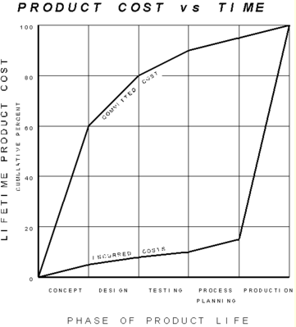

Figure 22

The image above can give us a better understanding of the situation. “By the time a product has been designed, only 8% of the total product budget has been spent. By that time, the design has determined 80% of the cost of the product!  The design determines the manufacturability, which determines a significant part of the introduction and production cost (the 80%) of the product. Once this cost is locked in, it is difficult for manufacturing to remove it. Note that the concept or architecture alone determines 60% of the cost!”[14]

Another aspect to take into consideration is manufacturability. Nowadays with the advantages in technology and automation, design for manufacturability is very important in order for a project to be successful. When you optimize manufacturing functions like fabrication, assembly, test and repair, you assure the best cost, quality and reliability in your product. Design for manufacturability is not always easy, our team evaluate different options to accomplish this in our design. For example, simplify the design and reduce the number of parts. This principle ensures a more perfect product, reduce the cost of fabrication and assembly, and the automation process become easier and less expensive. Another point to consider is standardize and use common parts and materials to facilitate design activities. With the use of common parts we reduce the inventory, resulting in lower cost and higher quality. Design for easy fabrication is another principle that brings a lot of benefits to our project. For example, our product requires an electrical box that will hold the system inside and provide the required connection access points. In order to facilitate his machinability process we will avoid sharp corners, undercuts that require special operations, and hard material that difficult the fabrication process. In addition we will avoid unnecessary parts that involve extra effort or complex tooling. Mistake proof is another technique that assure a fast production, here we design our components in such a manner that they can only be assembled in one way. Finally, Design circuit printed boards for assembly could be a good approach for our design, since we will minimize soldering, use standard boards and panel size minimizing component variety and standardizing component packaging, which together will contribute to a fast production.

To conclude, we observed in this section that when planning a project is essential to make decisions on time in early stages of our design, this could save or sink our project. Also, we analyzed manufacturability and emphasized in the different principles that comprise our design.

1. ETHICAL CONSIDERATIONS AND SOCIAL IMPACT
2. *Ethical Considerations*

When the team starts developing the idea of our Smart Home System “Alfred”, one of the first objectives that comes to our mind was the desire of improving the quality of life of elderly and disable people. But we were aware that the use of human interfaces in the design of the smart home system could present several ethical issues, even more if the system is meant to be also used by people with any kind of disability of restriction (physical, cognitive, or sensorial). Therefore we were extremely careful with the design of the system; we develop the interface having in mind that all type of people could be accessing to the system, in that way we treat fairly all persons regardless of such factors as race, religion, gender, disability, age, or national origin. In the process of the design we also sought and accepted honest criticism of our technical work; we acknowledged and corrected errors, and credited the contributions of others. As new developers of technology, the assistance of our mentor was essential to achieve an improved project.

*After a meticulous ethical analysis of our project and taking into consideration that an ethical issue is everything that can affect the wellness of others, we realize that we could face a complex ethical dilemma in our way to the acceptance of our project. Where do people feel safer than at home? Most people feels their home as the safer and more comfortable place in the world; therefore, they, especially the elderly, can considered a smart technology as an intruder in their home, they can be afraid of losing control since smart home may use systems that could affect the privacy and the autonomy of users. Saying this, we had to be clear about the advantage of the smart home system to those people versus the discomfort that it may create in their lives, and decided how to implement the system in a way that do not take them out of their comfort zone.*

Once we had identified the ethical issue, we concentrate in how to resolve the issue leading to the widely acceptance of our project. We realize that we need to create a system that had to be destined for extremely varied users and that needed to consider the habits of the intended users. We decide that those people who could feel uncomfortable with the smart home system should not be force to accept it because that could direct them to a total rejection of the technology. On the contrary they should be first informed, educated, and trained about all the advantage of the system, how it works, and all the benefits that it could bring them, because the acceptance of a product depends on the customer’s understanding of its functionality, utility, and advantages.

All this examination takes us to realize that the ethical analysis in every project is crucial and that we need to be aware of how the development of some ideas which lead to the production of new technology can have side effects, personal or social, over some of the intended users. The solution is recognizing the ethical issue, understand the perspective of the affected people and resolve the problem focused in the greatest benefit for the greatest number.

1. *Social Impact*

Smart Home Systems have been in the mind of people for many years, but it was just science fiction coming from movies and books until it actually became real. In the last few years, not only became real a systems that the user can manage to improve the quality of their lives by making homes a more comfortable place, but also its use around the world has become a trend that only lead to a more increasing use every year.

Last year the global smart homes market was valued at $20.38 billion; with the current trending to upgrade homes to smart homes in the majority of the developed countries, the market is expected to growth at an estimated compound annual growth rate (CAGR) of 17% between 2015 and 2020, consequently the estimated size for the market by 2020 is $58.68 billion.

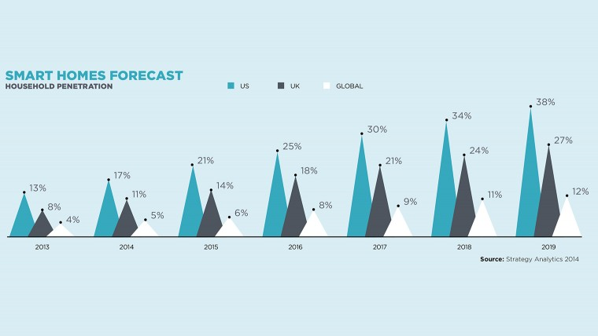

Figure 23

1. Local Culture

If for local culture we took our country, we can said that we are in the right place to develop a project like this, because, as can be seen in Figure 23, United States leads the use of smart home systems, and it is expected to continue being like this for the next years.

1. Global Culture

Although not to the same rate of in United States, the global growth of the utilization of smart home systems is also expected to increase in the coming years. The estimates suggest approximately 26 billion of smart homes by 2020 across the world. Of course this number is not evenly distributed, the majority of the smart homes will be in North America, follow by Europe (mainly United Kingdom, France and Germany), and by Asia (mainly China, Japan, and India). In the other hand, there will be regions in which the utilization of smart home systems will be scarce or null; for example, in the majority of the countries of Africa, Central and South America.

For a revolutionary idea to be successful it not just needs to be great; it also needs people to be ready to accept it and embrace it, and the global community has been anxious for the integration of technology and services through home networking for a better quality of living. Our project is something that people is actually waiting to hear from.

1. CONCEPT DEVELOPMENT

Our objective is to create a smart home system that can be mange though voice commands as well as a smartphone application, make phone calls, check the security of the users’ house and alert them if there is any door or window open, and the system must also be able to turn on and off the lights of at least four areas of the house as well as opening and closing the garage door. The system must be affordable, easy to use, user friendly for every age, especially for elders, and those not so acquainted with technology.

**Concept Fan**

The following concept fan will help us see the option we have available to design our Smart Home system, and implement the best concept for our design. The design chosen must keep us with in our objectives, budget and time.

Figure 24

1. *Concept Combination 1*

|  |  |  |  |  |  |  |  |  |  |  |
| --- | --- | --- | --- | --- | --- | --- | --- | --- | --- | --- |
| Voice Recognition |  | Phone Calls |  | Windows and Doors Security |  | Wi-Fi Module |  | Turn On and Off Lights |  | Open and Closing Garage Door |
| **------------------------------------------------------------------------------------------------------------------------** | | | | | | | | | | |
| EasyVR Shield | |  | | --- | |  | | FONA 800 Shield |  | Magnetic Door Switches |  | Dragino Yun Shield |  | Triac Board |  | Triac Board |
|  |  |  |  |  |  |  |  |  |  |  |
| BitVoicer |  |  |  |  |  | WiFi Module – ESP8260 |  | Relay Board |  | Relay Board |

Table 50

Advantages:

This option allows the system to not only have a one user but many since the BitVoicer will not have a voice recognition but a command recognition. The WiFi Module – ESP8260 allows the Arduino to connect to the internet, the relay will allow the system to control AC lights, and the Triac board will allow the system to control the garage door.

Disadvantages:

If a BitVoicer is use in the system anyone that comes into the house will be able to control the system and will not have much security for the user, since it does not have a voice recognition but a command recognition, the Relay will not support a high load from lights, and the Triac board will be too expensive just to handle the opening and closing of garage door.

1. *Concept Combination 2*

|  |  |  |  |  |  |  |  |  |  |  |
| --- | --- | --- | --- | --- | --- | --- | --- | --- | --- | --- |
| Voice Recognition |  | Phone Calls |  | Windows and Doors Security |  | Wi-Fi Module |  | Turn On and Off Lights |  | Open and Closing Garage Door |
| **---------------------------------------------------------------------------------------------------------------------------------------** | | | | | | | | | | |
| EasyVR Shield | |  | | --- | |  | | FONA 800 Shield |  | Magnetic Door Switches |  | Dragino Yun Shield |  | Triac Board |  | Triac Board |
|  |  |  |  |  |  |  |  |  |  |  |
| BitVoicer |  |  |  |  |  | WiFi Module – ESP8260 |  | Relay Board |  | Relay Board |

Table 51

Advantages:

This option allows the system to not only have a one user but many since the BitVoicer will not have a voice recognition but a command recognition. The Wi-Fi Module – ESP8260 allows the Arduino to connect to the internet, and the Triac will allow a high load from lights to be manage, and the Relay board will allow us to manage the load of the garage door.

Disadvantages:

If a BitVoicer is use in the system anyone that comes into the house will be able to control the system and will not have much security for the user, since it does not have a voice recognition but a command recognition, the Wi-Fi Module – ESP8260 is not as reliable as other modules or shields in the market, and the Triac is more expensive than the Relay.

1. *Concept Combination 3*

|  |  |  |  |  |  |  |  |  |  |  |
| --- | --- | --- | --- | --- | --- | --- | --- | --- | --- | --- |
| Voice Recognition |  | Phone Calls |  | Windows and Doors Security |  | Wi-Fi Module |  | Turn On and Off Lights |  | Open and Closing Garage Door |
| **---------------------------------------------------------------------------------------------------------------------------------------** | | | | | | | | | | |
| EasyVR Shield | |  | | --- | |  | | FONA 800 Shield |  | Magnetic Door Switches |  | Dragino Yun Shield |  | Triac Board |  | Triac Board |
|  |  |  |  |  |  |  |  |  |  |  |
| BitVoicer |  |  |  |  |  | WiFI Module – ESP8260 |  | Relay Board |  | Relay Board |

Table 52

Advantages:

This option allows the system to have the security of voice recognition, and not everyone coming to the house will be able to use the system but only the house owner. The Dragino Yun Shield allows the Arduino to connect to the internet and it is reliable, and the Triac will allow to control the lights and not have and overload, the relay for the garage door will not be expensive for only one load.

Disadvantages:

The Triac board is more expensive than a Relay board.

1. *Concept Selection*

|  |  |  |  |  |  |  |
| --- | --- | --- | --- | --- | --- | --- |
|  | **Sound Quality** | **Easy to Use** | **Good Phone Connection** | **Security** | **Accuracy** | **Low Cost** |
| **Sound Quality** | 1 | 3 | 1 | 7 | 3 | 3 |
| **Easy to Use** | 1/3 | 1 | 3 | 5 | 5 | 3 |
| **Good Phone Connection** | 1/1 | 1/3 | 1 | 3 | 3 | 3 |
| **Security** | 1/7 | 1/5 | 1/3 | 1 | 1 | 3 |
| **Accuracy** | 1/3 | 1/5 | 1/3 | 1/1 | 1 | 1 |
| **Low Cost** | 1/3 | 1/3 | 1/3 | 1/3 | 1/1 | 1 |

Table 53

|  |  |  |  |  |  |  |  |  |
| --- | --- | --- | --- | --- | --- | --- | --- | --- |
|  | **Sound Quality** | **Easy to Use** | **Good Phone Connection** | **Security** | **Accuracy** | **Low Cost** | **G. Mean** | **w** |
| **Sound Quality** | 1 | 3 | 1 | 7 | 3 | 3 | 2.395577915 | 0.32 |
| **Easy to Use** | 0.33 | 1 | 3 | 5 | 5 | 3 | 2.053573307 | 0.28 |
| **Good Phone Connection** | 1.00 | 0.33 | 1 | 3 | 3 | 3 | 1.44224957 | 0.19 |
| **Security** | 0.14 | 0.20 | 0.33 | 1 | 1 | 3 | 0.552911122 | 0.07 |
| **Accuracy** | 0.33 | 0.20 | 0.33 | 1.00 | 1 | 1 | 0.530230348 | 0.07 |
| **Low Cost** | 0.33 | 0.33 | 0.33 | 0.33 | 1.00 | 1 | 0.480749857 | 0.06 |
|  |  |  |  |  |  | **Total** | 7.455292119 |  |

Table 54

The above tables allows us to see which the most important objectives are for our Smart Home System. By calculating the G. Mean and the weight we will be able to choose the best option available for us to build our system.

|  |  |  |  |  |  |  |  |
| --- | --- | --- | --- | --- | --- | --- | --- |
|  |  | **Option 1** | | **Option 2** | | **Option 3** | |
| **Constrains** |  |  | |  | |  | |
| **Operable by Voice** |  | Yes | | Yes | | Yes | |
| **Phone Application** |  | Yes | | Yes | | Yes | |
| **Small to Fit in a Closet or Attic** |  | Yes | | Yes | | Yes | |
|  |  |  |  |  |  |  |  |
| **Objectives** | **w** |  |  |  |  |  |  |
| **Sound Quality** | 0.32 | 4 | 1.285 | 4 | 1.285 | 5 | 1.607 |
| **Easy to Use** | 0.28 | 3 | 0.826 | 3 | 0.826 | 5 | 1.377 |
| **Good Phone Connection** | 0.19 | 5 | 0.967 | 5 | 0.967 | 5 | 0.967 |
| **Security** | 0.07 | 2 | 0.148 | 2 | 0.148 | 5 | 0.371 |
| **Accuracy** | 0.07 | 3 | 0.213 | 3 | 0.213 | 5 | 0.356 |
| **Low Cost** | 0.06 | 4 | 0.258 | 3 | 0.193 | 3 | 0.193 |
|  |  |  | 3.699 |  | 3.634 |  | 4.871 |

Table 55

After the calculations are made comparing each of the three options we have available, the best option is option number three with a result of 4.871 which is the highest one we have available. We will be using a EasyVR Shield for our voice recognition, for phone calls FONA 800 Shield, for the Windows and Doors Security we need to connect to the Arduino Mega 2560 directly and the use if the Wi-Fi Module to connect the system to the smartphone application for our best option we will be using the Dragino Yun Shield, and to have the system control the lights we will be using a Triac Board and the garage door will be open and close through a Relay.

1. END PRODUCT DESCRIPTION AND OTHER DELIVERABLES

Having now a clear path to follow thanks to the calculations made on the concept development section of this document. We can explain on more detail each of the modules that are to be used in our Smart home system. As we concluded on the previous section our best option to create our Smart Home System with all of the functionality have planned is to follow the path of the concept combination table 3; although, in the development of the hardware and software of the system things may change. To build our smart home system we will make our main unit an Arduino Mega 2560, which will be the brain of the operation, this device will manage the functionalities of the system; which are a voice recognition system, make phone calls, check the status of doors and windows in the house weather they are open or close, and it will be able to control the light of the house as well as the garage door.

1. *End Product Description*

In our end product description of our proposal, we will provide information about how our product will work in different levels, also it will describe the systems functionality. Each of this section will give more light on what type of modules and boards of existing technology we will be using to provide the functionality to the Smart Home System.

**Level 0**

Smart Home System / Arduino Mega 2560

Audio Output Signal

Audio Input

Lights

Power

Door Control

Door / Windows Status

App Command

Figure 25

|  |  |
| --- | --- |
| **Module** | **Smart Home System / Arduino** |
| **Inputs** | - Power: 7 to 12V DC |
|  | - Audio Input: Mic Sensitivity - 38dB (0dB = 1V/Pa at 1KHz) |
|  | - Load Impedance 2.2K |
|  | - Operating Voltage 3V |
|  | - Almost Flat Frequency response in the range of 100Hz - 20kHz  - Magnetic contact switches |
|  | - App Control: Software (User Interface) |
| **Outputs** | - Triac board / Control lights |
|  | - Relay board / Garage door control |
|  | - Audio output: 8 Ω speakers |
|  | - WiFi Module  - Magnetic contact switch status |
| **Functionality** | Main unit that will manage the whole smart home system |

Table 56

The above graph and table, is depicting the Smart Home system with its input and outputs, without specifying what is inside the box. As it is observed, the expected inputs are the power that could have a range from 7 to 12 V DC. Also, an audio input which will be done by using a microphone with the correct gain allowing the user to give commands to the system form at least 3 meters, the microphone will have a sensitivity of at least -38dB, a load impedance of 2.2k, an operating voltage 3V and almost flat frequency response in the range of 100Hz to 20kHz. Finally, the smart phone application, which will allow the user to interact with the system without the voice command if it is so desired, this application will be connected to the system through the Wi-Fi module.

The system’s outputs will be seen in it functionalities which are to allow the user to control the lights of the home, the garage door, the system will also allow the user to know that is listening waiting for a command by giving a short sound through the speaker, and for the phone functionality the speaker will allow the user to hear the other person on the other side of the call, also the system will send a status to the user of the magnetic contacts placed at the windows and doors, to let him know if the windows or doors are open or close.

The system’s main devise that will be use and will control the input and outputs through the correct channels will be an Arduino Mega 2560, which is compatible with the rest of the modules to be use in the complete system.

**Level 1 - Smart Home System**

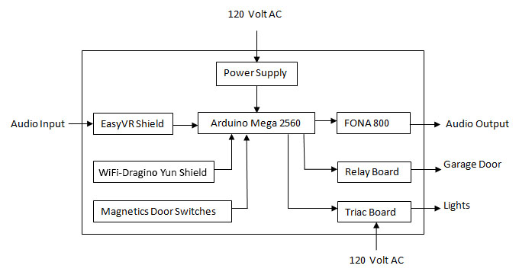

Figure 26

|  |  |
| --- | --- |
| **Module** | **Smart Home System Modules** |
| **Inputs** | - Power: 7 to 12V DC |
|  | - Audio Input: Easy Shield: Mic Sensitivity - 38dB (0dB = 1V/Pa at 1KHz) |
|  | - Load Imp2.2K |
|  | - Operating Voltage 3V |
|  | - Almost Flat Frequency response in the range of 100Hz - 20kHz  - Magnetic door switches |
|  | - WiFi – Dragino Yun Shield user interface with phone application |
| **Outputs** | - FONA 800 audio output from calls |
|  | - Arduino Mega 2560 will send the status of the magnetic door switches |
|  | - Triac board: turn on and off lights  - Relay board: opens and closes garage door |
| **Functionality** | The system will send information to the user letting them know if the windows are open or close. The FONA 800 allows the user to make phone calls and hear the person on the other line. The Wi-Fi module will allow the smartphone application to interact with the system. The Triac will allow the user to control the lights and the Relay board will control de garage door. |

Table 57

On the Level One graph and functionality table we can observe the system in more detail, the inputs to the system depend on the voice commands given by the user or the phone application that the user can also use. If the home owner uses the voice command the input will be receive through the EasyVR Shield which will send the command to the Arduino Mega 2560 and the Arduino will decide which interface will be the one performing the action. The other input received by the system is through the smartphone application which will send the command to the Arduino through the Wi-Fi – Dragino Yun Shield, the Arduino will also receive a signal from the Magnetic door switches to let the system know the status of each door and window that has one, weather they are open or close.

The system uses modules to send the output signals and perform the command the user requires. Through the Wi-Fi – Dragino Yun Shield the system will be sending the status of the doors and windows of the house to the user’s phone app, through the FONA 800 the system will be able to make phone calls and by using 8Ω speaker connected to this module it will allow the user to hear the person on the other line. The other important output the system has is done through the Triac Board, which will allow the lights of the house to turn on and off, finally the garage door will be open and close by the system through a Relay Board.

Following we will go through the level two graphs and tables of each module that is used in the system to give functionality needed by the user.

**Level 2 - EasyVR Shield**

3.3V DC Input

8Ω Speakers

Audio Input

Arduino

3.5 mm Speaker Jack

MIC Input

Microcontroller

Power Management

Figure 27

|  |  |
| --- | --- |
| **Module** | **EasyVR Shield** |
| **Inputs** | - 3.3V DC form Arduino Mega 2560 |
|  | - Audio Input: Voice command form user |
| **Outputs** | - Data command to Arduino |
|  | - Audio tone to confirm the command to the user, through speakers |
| **Functionality** | Convert voice command input to digital data and send it to the Arduino unit, also to confirm the voice command. |

Table 58

The EasyVR Shield is a module that is compatible to the Arduino Mega 2560 and will allow the Arduino to receive voice command from the user, this module is being powered by the 3.3 Volts supplied by the Arduino boar. Once the command is recognized the EasyVR Shield will give a tone through the speaker to let the user know that the command was received and will be perform. The voice recognition will give the facility to the user to only have to speak and the system will do what the command says, this functionality is being implemented for the users that do not have the ability to use smart phones and its applications or simply because they have a type of disability that will give them the advantage to interact with the system.

**Level 2 - FONA 800**

Audio Input

Audio Output

Audio Interface

Power Supply

Digital Based Band

Analog Base Band

Power Management

Figure 28

|  |  |
| --- | --- |
| **Module** | **FONA 800** |
| **Inputs** | - 3.3V DC form Arduino Mega 2560 |
|  | - Audio Input: Microphone: Microphone Sensitivity -38dB (0dB = 1V/Pa at 1kHz) |
|  | - Load Impedance 2.2k |
|  | - Operating Voltage 3V |
|  | - Almost flat frequency response in the range of 100Hz to 20kHz |
| **Outputs** | - External 8 Ω speaker |
| **Functionality** | Make and receive phone calls |

Table 59

The system will also be able to make phone calls and this will be done using the FONA 800 Module, this module is compatible with the Arduino Mega 2560. The FONA 800 will be power by the 3.3V DC supplied by the Arduino Mega 2560, also, the module will be receiving the command to make a phone call prom the Arduino and receive an audio input from the microphone once a phone call is in line. The output of the FONA 800 is through the speakers while the user is in a phone call.

**Level 2 – Magnetic Door Switches**

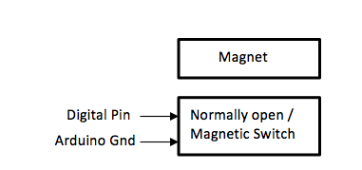

Figure 29

|  |  |
| --- | --- |
| **Module** | **Magnetic Door Switches** |
| **Inputs** | - Digital Pin 3V from Arduino unit |
|  | - Arduino Ground |
| **Outputs** | - Switch status |
| **Functionality** | Send status of windows and doors to the Arduino Mega 2560 |

Table 60

One of the functions of our system is to check the security status at the user’s home. This will be able to be done through a Magnetic Door Switches connected to the Arduino board. The Arduino Mega 2560 will send a signal of 3V to the contact switches and corroborate if the switches are open or closed.

**Level 2 - WiFi Module – Dragino Yun Shield**

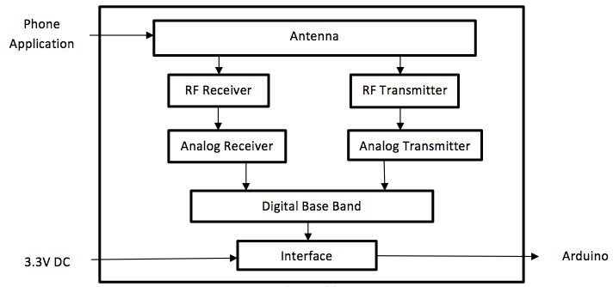Figure 30

|  |  |
| --- | --- |
| **Module** | **WiFi Module – Dragino Yun Shield** |
| **Inputs** | - 3.3V DC from Arduino Mega 2560 |
|  | - User interface (phone Application) |
| **Outputs** | - Send message command from phone application to the Arduino  - Send the status of the doors and windows to the phone for the user to check. |
| **Functionality** | Receive commands from the user’s phone app to send it to the Arduino allowing the user to interact with the system. It also allows the user to check the status of the doors and windows. |

Table 61

With the Wi-Fi Module – Dragino Yun Shield the system will have the ability to connect to the Wi-Fi to implement other functions the system needs to perform. The Dragino Yun Shield is compatible with the Arduino Mega 2560 and allows the Arduino to send information and receive commands through the Wi-Fi module. In our system the Wi-Fi module will interact with the user interface which in our case is the phone application. Once the Module receives any of the inputs it will send the information to the Arduino which will process the information and decide what is the next step depending on the input. If the Arduino wants to send information to the phone application like the status of the magnetic switches to let the user know if a window or door is open then it will send the information through the Dragino Yun Shield.

**Level 2 - Triac Board**

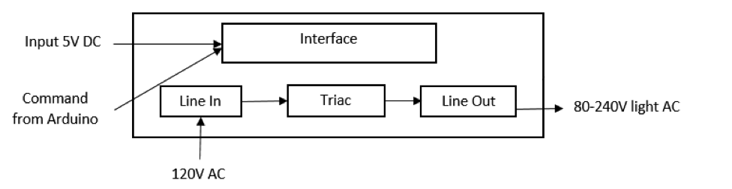

Figure 31

|  |  |
| --- | --- |
| **Module** | **Triac Board** |
| **Inputs** | - 5 V DC from Arduino |
|  | - Command from Arduino |
|  | - 120V AC that feeds the loads |
| **Outputs** | - 120V AC lights |
| **Functionality** | Manage different loads controlled by the Arduino Mega 2560 |

Table 62

One of the most important functions of our system is to turn on and off lights at the user’s home. This will be able to be done through a Triac Board which allows us to control high loads though the Arduino Mega 2560. The Triac board is be power by the 5V DC supplied by the Arduino, it will also receive commands from the Arduino to know which load will be turn on, off. Also, the board requires a 120V AC input that will feed all the loads that are connected to it. Once the inputs for the Triac Board are met, the loads that in this case are the will be able to be controlled by the user through the Arduino Mega 2560.

**Level 2 - Relay Board – KY-019**

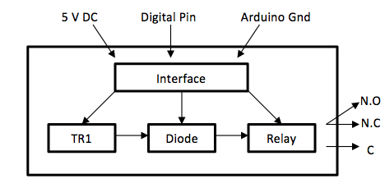

Figure 32

|  |  |
| --- | --- |
| **Module** | **Relay Board – KY-019** |
| **Inputs** | - 5 V DC from Arduino |
|  | - Command from Arduino – Digital Pin |
|  | - Arduino ground |
| **Outputs** | - Normally Open  - Normally Close |
|  | - Common |
| **Functionality** | Allows the system to open and close the garage door. |

Table 63

One of the functions of our system is to open and close the garage door. This will be able to be done through a Relay Board which allows us to control high loads though the Arduino Mega 2560. The Relay board is powered by the 5V DC supplied by the Arduino, it will also receive commands from the Arduino to know when to open or close the garage door. Once the inputs for the Relay Board are met, the load that in this case is the garage door motor will be able to be controlled by the user through the Arduino Mega 2560.

The previews graphs and tables provides more information on how the hardware of the system is interconnected.

1. PLAN OF ACTION

A good plan of action is very important in order to deliver a successful end product design. In this section we are going to use "Open Workbench", a planning software tool that gives you the facility to organize your project phases and tasks, We will also assign team members to different tasks and define milestones.

Below we can see the required phases and tasks to obtain our design and the responsible team members and other resources related to them.

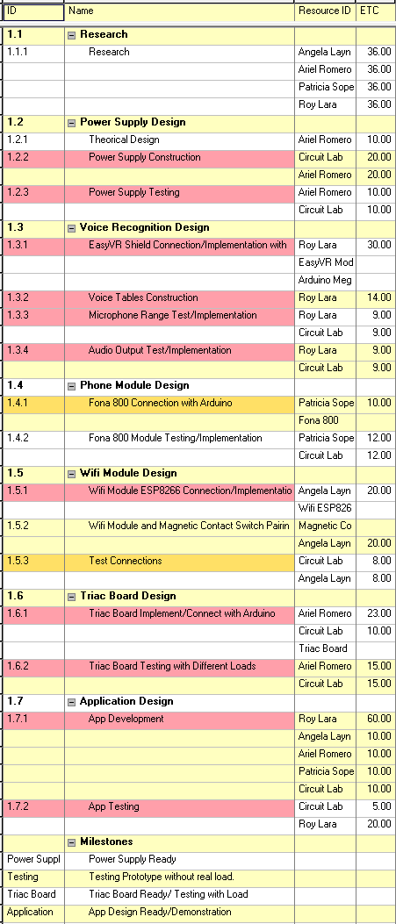

Table 64 – Proposed Task Chart

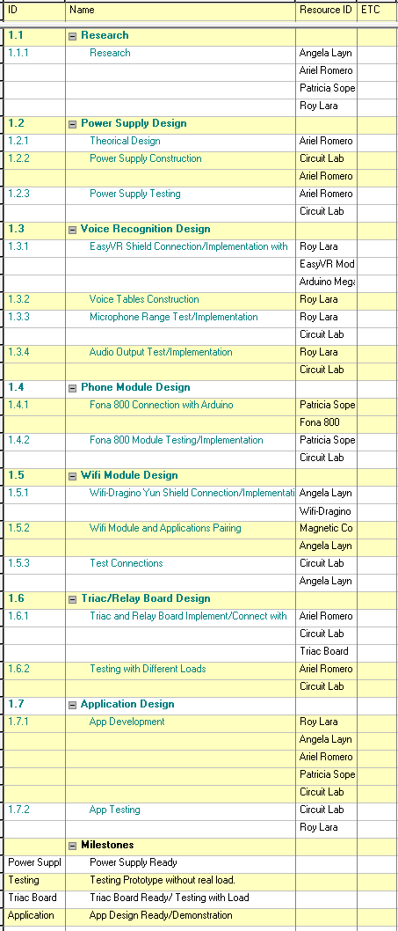

Table 65 – Final Task Chart

On the final task chart the only things that change from the proposed project to the final was the unit that is being used for the Wi-Fi, originally we were going to use a ESP8260 but we decided to use the Dragino Yun Shield. The other thing that changed was that we were only going to use a Triac board, but decided to use a Triac board for the lights and a relay for the garage due to the difference in voltage.

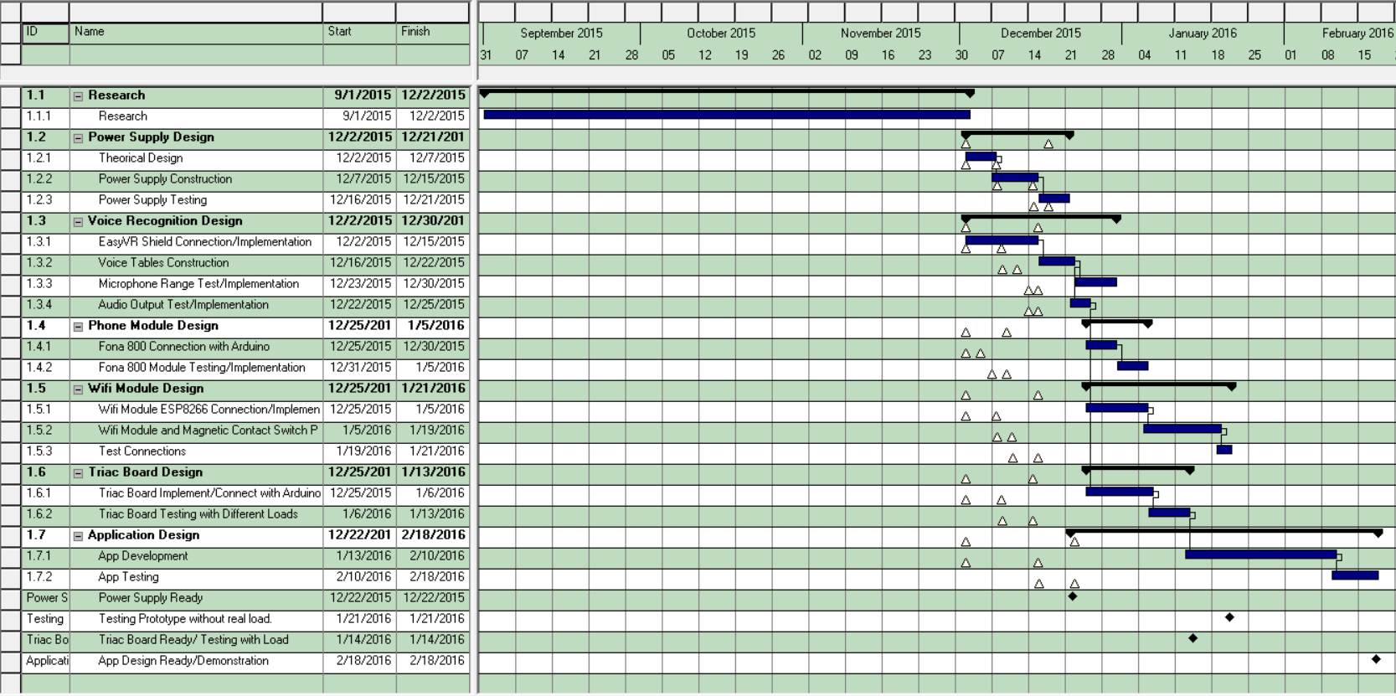 Below there is the Gantt Charts from our planning software Open Workbench.

Table 66 – Proposal Gantt Chart

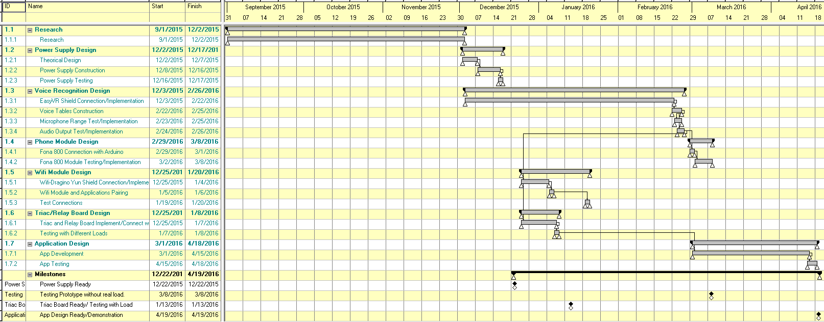

Table 67 – Completed Project Gantt Chart

As the development of the project started, there were many things that changed along the way, as it can be observe on tables 65 and 66. These tables show the proposed Gantt Chart and the Gantt Chart we ended up with at the end of the project. The milestones and tasks did not change, the major changes we had were in the time that took to complete each task. The project took longer to finish than what was originally expected, originally the project was going to be finished by mid-February of 2016 but instead it lasted until mid-April 2016. Even though the task did not change, a module that was going to be used did changed, which is the WiFi module.

PERT diagrams that show the dependency of our phases and tasks.

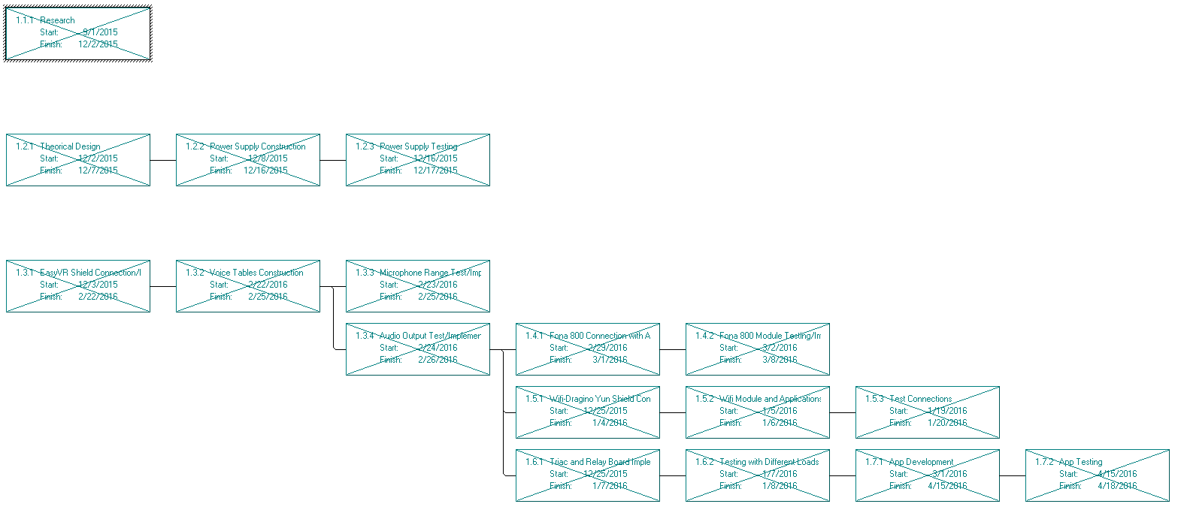

Figure 33 – PERT Diagram

**Work Breakdown Structure**

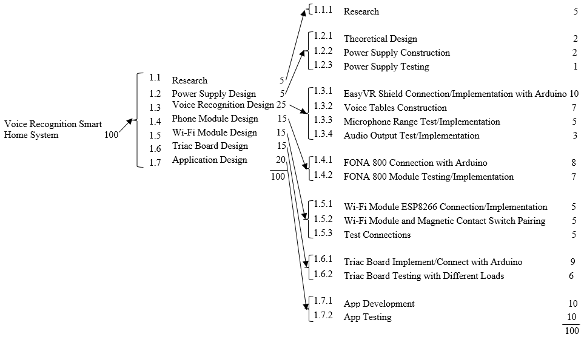

Figure 34 – WBS Proposed

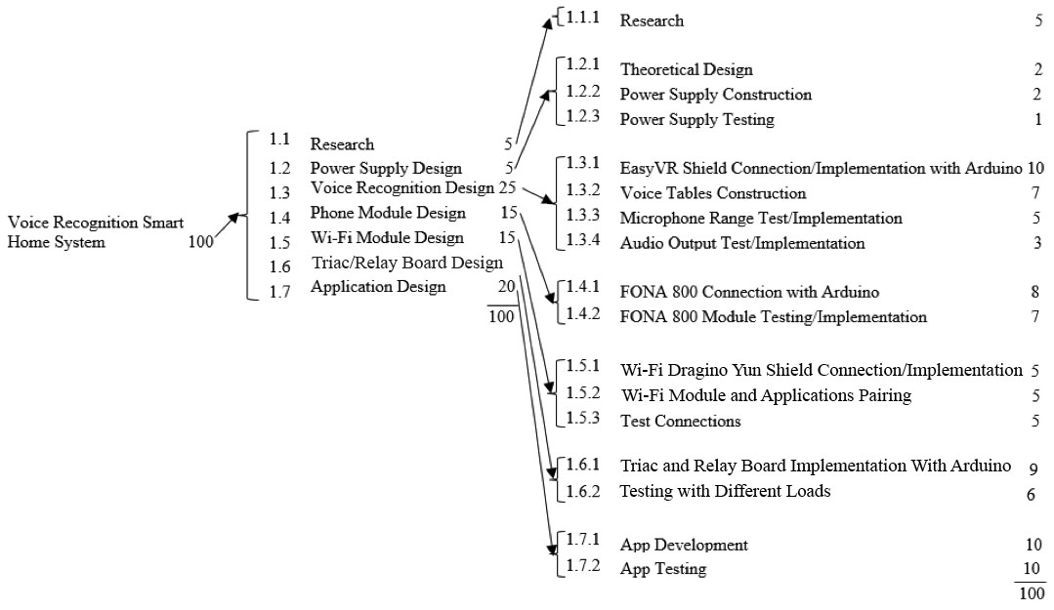

Figure 35 – WBS Final

The Work Breakdown Structure has the same weight in each task. However the WiFi module change from ESP8266 to the Dragino Yun Shield, and to the 1.6 task we were only going to use a Triac board for the lights and the garage door, we decided to use a Triac board for the lights and a relay board for the garage door.

**Documenting WBS**

**Phase 1.1 –Research**

* Objectives: To determine the tasks that the system will be performing for the end user and how it will be done; what hardware and software will be used to be able to perform each task required by the client and end user.
* Approach: Client interview, survey to intended end users, online research to determine the best hardware to be used.
* Expected Results: Obtain list of objectives and modules to be used in the construction and programming of the system.

**This phase will consist of the following tasks:**

* Research

**Phase 1.2 -Power Supply Design**

* Objective: To construct a 12 volt DC power supply capable to feed the Arduino unit and the different modules.
* Approach: Since the Arduino unit can work in a voltage range between 7v to 12v a variable Power supply can be built and will feed the different modules independently if it would be necessary.
* Expected Result: Power Supply capable to handle all modules load.

**This phase will consist of the following tasks:**

* Theoretical Design
* Power Supply Construction
* Power Supply Testing

**Phase 1.3 - Voice Recognition Design**

* Objective: Implement a voice recognition module in order to make the system capable to execute voice commands.
* Approach: We will use an EasyVR shield coupled with the Arduino unit, implementing input and output range.
* Expected Results: The users will be able to communicate with the system with their voice.

**This phase will consist of the following tasks:**

* EasyVR Shield Connection/Implementation with Arduino
* Voice Tables Construction
* Microphone Range Test/Implementation
* Audio Output Test/Implementation

**Phase 1.4 - Phone Module Design**

* Objective: To make the system able to communicate with a user’s built-in contact list and make calls.
* Approach: We are going to use a FONA 800 module implemented with options for Sim card.
* Expected Results: System able to make phone calls.

**This phase will consist of the following tasks**:

* FONA 800 Connection with Arduino
* FONA 800 Module Testing/Implementation

**Phase 1.5 - Wi-Fi Module Design**

* Objective: To implement a Wi-Fi module in order to communicate the system with the smart phone app.
* Approach: We will use a Module Dragino Yun Shield that will be implemented for work with the Arduino unit.
* Expected Results: Strong Wi-Fi connection.

**This phase will consist of the following tasks:**

* Wi-Fi Module Dragino Yun Shield Connection/Implementation
* Wi-Fi Module and smartphone application communication
* Test Connections

**Phase 1.6 - Triac and Relay Board Design**

* Objective: A Triac board capable of handling considerable high loads. A Relay board capable of handling a high load.
* Approach: We are going to design or implement an existing Triac board to be able to control at least four areas of lights and implement a Relay board to control a garage door. From the Arduino unit.
* Expected Results: Triac board that communicates with the Arduino unit and controls the different lights of the house. Relay that communicates with the Arduino unit and controls the garage door of the house.

**This phase will consist of the following tasks:**

* Triac Board Implement/Connect with Arduino
* Triac Board Testing with Different Loads
* Relay Board Implement/Connect with Arduino
* Relay Board Testing with a load

**Phase 1.7 - Application Design**

* Objective: An application that connects the user with the system through their phone or tablet.
* Approach: Explore different programming methods.
* Expected Results: Easy to use and functional app.

**Milestones:**

* **Power Supply Ready**

This is our first milestone, now we can test our design with its own power supply.

* **Testing Prototype without real load.**

In this stage we are ready to test our system and see how the voice recognition works, if everything works fine then the project is ready for the next milestone.

* **Triac Board Ready/ Testing with Load**

Here we will test our system with real loads.

* **App Design Ready/Demonstration**

At this point our system is ready to work as a unit.

To conclude, we think that the use of Open Workbench to plan our design path was very helpful. If we follow our Work Breakdown Structure chart we will finish our project on time.

1. MULTIDISCIPLINARY ASPECTS

Although we come from similar fields, it is in the concentrations, employment, and extracurricular activities that we identify the various aspects of multiple disciplines that will contribute to this project. Below are those aspects.

1. Angela Layne

* Dual majored in Electrical and Computer Engineering.
* Prior research and analysis experience on non-traditional security threats.
* Familiarity with medical design.
* Currently working in the aerospace industry.

1. Ariel Romero

* Former Electrician
* Electrical Engineer
* Proven leader while developing thermoelectric flashlight, using the palm as a power source to heat power the flashlight

1. Patricia Rodriguez

* Electrical Engineer
* Integrated Nanotechnology
* Bio-Engineering
* Proven leader while developing a permanent magnet generator with a micro air turbine

1. Roy Lara

* Computer Engineer
* Proven aptitude in computer programming and mathematics through various intercollegiate programming competitions.
* Displays charismatic showmanship.
* Tinker of embedded systems.

During the break as to not let up we shall try to meet as often as possible to work on the system so as to not have to hit the ground running.

In closing, we are versed in a motley sort of virtues that will contribute to the excellence that will be our final product.

1. PERSONNEL
2. *Roy Lara*

**Education:** Florida International University, Miami, FL

**Bachelor of Science in Computer Engineering**

Concentrations: Computer Science & Embedded Systems

GPA: 3.00/4.0 Graduation: Spring 2016

**Related Courses:**

|  |  |
| --- | --- |
| * Computer Science | * Operating Systems |
| * Programing Embedded Systems | * Communication System |
| * Algorithm Techniques |  |

**Leadership / Community Involvement:**

17th ACM ICPC USA Southeast Regional 2013

Learning Assistant – Calculus I, Tebou 2013

* Met with students regularly and upon request

**Membership:**

Institute of Electrical and Electronics Engineers

Current President of Panther Linux User Group

**Multidisciplinary Aspects:**

* + Computer Engineer
  + Proven aptitude in computer programming and mathematics through various intercollegiate programming competitions.
  + Displays charismatic showmanship.
  + Tinker of embedded systems.

1. *Angela Layne*

**Education:** Florida International University, Miami, FL

**Bachelor of Science in Electrical Engineering and Computer Engineering**

Concentrations: Integrated Nano-Technology, Communications, Bio-Engineering & Embedded Systems

GPA: 3.00/4.0 Graduation: Spring 2016 in Electrical Engineering, continuing Computing engineering

**Related Courses:**

|  |  |
| --- | --- |
| * Electronics I | * Medical Instrumentation Design |
| * Electronics II | * Computer Application in Electrical Engineering |
| * Introduction to Solid State Devices * Communication System * Introduction to DSP | * Programing Embedded Systems * Embedded Computing |

**Relevant Projects:**

Research Assistant, Applied Research Center at FIU 2011 - 2012

* Western Hemisphere Information Exchange Program (WHIX); Environmental Security Research Projects, providing research and analysis on non-traditional security threats, and developing viable solutions involving natural resources and the environment. (Medical tent where for disasters or wars that can be used for surgery with the latest technology and is powered by solar, and wind energy).

**Multidisciplinary Aspects:**

* + Dual majored in Electrical and Computer Engineering.
  + Prior research and analysis experience on non-traditional security threats.
  + Familiarity with medical design.
  + Currently working in the Aerospace industry.

1. *Patricia Sopena*

**Education:** Florida International University, Miami, FL

**Bachelor of Science in Electrical Engineering**

Concentrations: Integrated Nano-Technology & Bio-Engineering

GPA: 3.80/4.0 Graduation: Spring 2016

**Related Courses:**

|  |  |
| --- | --- |
| * Power Systems I | * Communication Systems |
| * Electronics II | * Intro to DSP |
| * Integrated Circuits and Systems | * Telecommunication Network Security |

**Relevant Projects**

Permanent Magnet Generator powered by a Micro Air Turbine ProjectSpring 2015

* Lead a team of 5 to develop a permanent magnet generator (PMG) using an air-pressured turbine to power an LED.
* Our project consisted of two main components, a Micro Air Turbine and a Permanent Magnet Generator; both were entire build by the team.

Finger Pulse Display Module (Photoplethysmographer) Fall 2014

* Participated with a team of biomedical engineering students building a finger pulse display module.
* We used an LED light source and a phototransistor light receiver to create an electrical signal that indicates the pulse motion of blood through the fingertip with each heartbeat. This signal was processed to produce a display of that pulse on a 10-LED bar graph.

**Multidisciplinary Aspects:**

* + Electrical Engineer
  + Integrated Nanotechnology
  + Bio-Engineering
  + Proven leader while developing a permanent magnet generator with a micro air turbine

1. *Ariel Romero*

**Education:** Florida International University, Miami, FL

**Bachelor of Science in Electrical Engineering**

Concentrations: Integrated Nano-Technology & Network Engineering

GPA: 3.13/4.0 Graduation: Spring 2016

**Related Courses:**

|  |  |
| --- | --- |
| * Electrical Design in Buildings I | * Logic Design |
| * Electronics II | * Fields & Waves |
| * Power Systems I | * Integrated Circuits |

**Relevant Projects:**

Thermoelectric Flashlight Spring 2015

* Led a team of 4 to build a thermoelectric flashlight. Led the research to be able to get the correct parts like the DC-DC converter and Peltier tiles.
* Was able to create enough heat from the palm of a hand to be able to boost more than 2 Volts to power a few LED’S.

**Multidisciplinary Aspects:**

* + Former Electrician
  + Electrical Engineer
  + Proven leader while developing thermoelectric flashlight, using the palm as a power source to heat power the flashlight

1. BUDGET

Every development project needs to have an analysis of all expenses that it could have during the concept design, testing, and production; in other words a deep look into the budget. The budget includes every single expense: charges for team members’ work, the use of labs, and the cost of all components. The budget shouldn’t be obtained by intuition; it has to be a result of the use of a project planning software. After entering all the information in the software used (Open Workbench), we obtained the estimated budget needed in order to bring our project to live. The results are shown in Table 69.

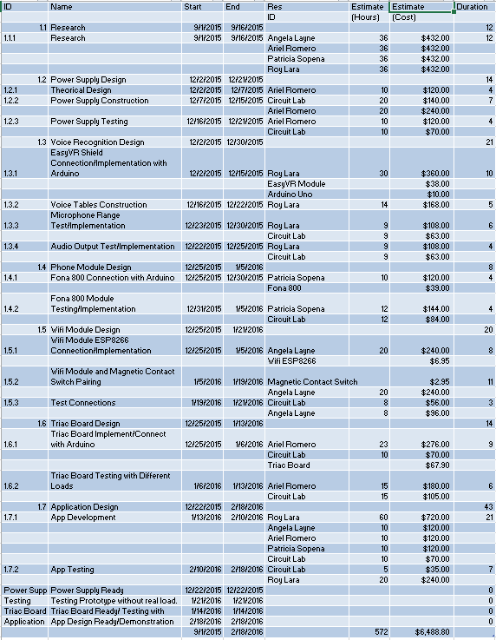

Table 68 – Proposed Budget

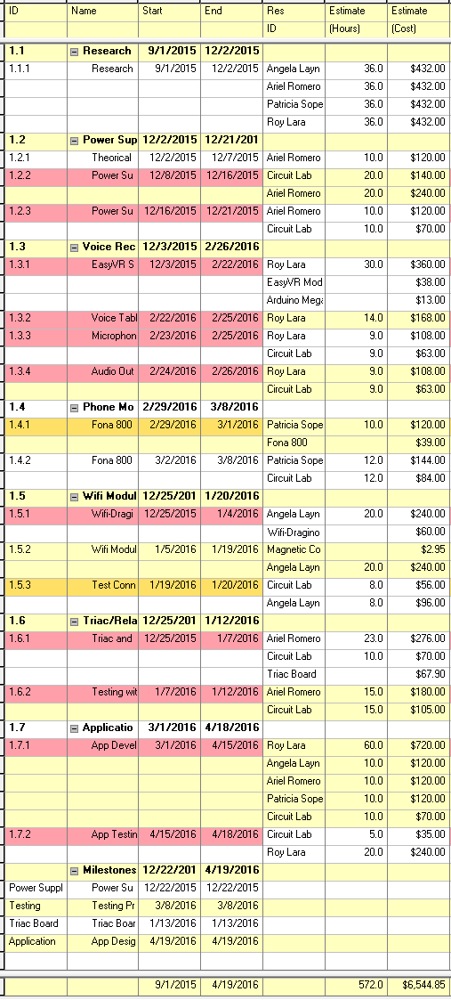

Table 69 – Final Budget

The budget change in the price of some of the materials acquired for the project. Originally the units we were going to use for the voice recognition system was the Arduino Uno, but instead we used the Arduino Mega 2560 which has a price difference of $3.00 USD. Another unit that changed was the Wi-Fi Module which originally was going to be an ESP8266 that had a cost of $6.95 USD and we ended up using a Dragino Yun Shield that costs $60.00 USD. In our proposed budget we were going to spend $6,488.80 USD in total, but we ended up spending $6,544.85 USD.

1. RESULTS EVALUATION

In this section our team will reemphasize the different objectives to be meet, the constraints to be satisfied, standards that our product will comply with, and patents not to infringe. In addition we are going to explain how these results will be evaluated at the end of our Senior Design II.

**During Senior Design I we were promising the following:**

***Objectives***

The objective of this project is to create an affordable smart home system using existing technology that will make life easier, not only for those who use the application on a smart phone, but also to those who are not so adept to technology. The system should be able to perform some basic functions like turning on and off lights via voice command or smart phone, among other objectives listed below.

The main objectives of the project are:

1. The system should be able to control lights from a variety of areas.
2. The system should be able to control the garage door.
3. The system should be able to check the doors and windows status.
4. The system should be able to make calls.
5. The system should have a moderate grade of installation difficulty.

***Constraints***

Our smart home system has constraints that could create limitations on it. However, those limitations will not make it impossible to build it and are only challenges to overcome. The constraints that we believe we are going to be encounter in the development of our system are listed below.

The constraints of the project are:

1. The system should be operable by voice, phone application and regular switches.
2. The system should be small enough to fit in a closet or attic.
3. The system should be one device.
4. The system should not use too much data.

*Standards Consideration*

These following standards published by the IEEE will be our guides when developing our system.

1. IEEE Std. 1905.1a-2014
2. IEEE Std. 1872-2015
3. IEEE Std. C62.36-2014

***Patents not to infringe***

The following three patents are relevant and appear on the United States Patent & Trademark Organization when ‘*home automation*’ is searched on the site’s engine. The first patent, Automation Control of Electric Devices, comes from Utah by W. E. Smith and J. R. Gist; followed by Voice Control Device and Voice Control Method by Guo-Feng Zhang of Shanghai China and finally, Actuator for Electric Blinds invented by Masanori Kobayashi, Niigata, Japan***.***

1. *Automation Control of Electronic Devices, US 9,152,139 B2*
2. *Voice Control Device and Voice Control Method US 9,153,232 B2*
3. *Actuator for Electric Blinds, US 4,773,464*

***Specifications***

|  |  |
| --- | --- |
| **Device** | **Specification** |
| **Arduino** | Uno |
| Input Voltage | 120 Volt |
| DC Operating voltage | 5 Volt |
| DC Current per I/O pin | 20 mA |
| **Voice Recognition module** | EasyVR Shield 3.0 |
| Mic | Horn EM9745P-382 |
| Sensitivity | -38dB (0dB=1V/Pa @1KHz) |
| Distance | 3 Meters |
| Sound output method | 3.5mm jack, and/or 8 ohm speaker |
| **Door Sensor** | Magnetic contact switch |
| Rated current | 100 mA max |
| Rated voltage | 200 VDC max |
| Distance | 15mm max |
| **Phone Shield** | FONA 800 Shield |
| Band | Quad-band 850/900/1800/1900MHz |
| Input | Electret Mic (Horn EM9745P-382) |
| Output | External 8Ω speaker |
| **Unit case** | JBH-4965-KO |
| Tentative Dimensions | 6” width x 8” Height x 4” Depth |

Table 70

Senior Design II will be a period of construction and engineering for our team. We are going to be working in constant contact with our client and experienced engineers to assure that our project meet all the requirements mentioned before. Besides that, at the end of the semester we will meet with our client in order to test and analyze our product. Our team will measure the different inputs and outputs in order to compare them with the initial promises. Finally we are planning to meet with different engineers to discuss the accomplishment of our standards and the patents that were promised not to infringe.

**During Senior Design II we accomplish the following:**

***Objectives***

The objective of this project was to create an affordable smart home system using existing technology that will make life easier, not only for those who use the application on a smart phone, but also to those who are not so adept to technology. The system is able to perform some basic functions like turning on and off lights via voice command or smart phone, among other objectives listed below. All of these objectives have been accomplish.

The main objectives of the project are:

1. The system is able to control lights from a variety of areas.
2. The system is able to control the garage door.
3. The system is able to check the doors and windows status.
4. The system is able to make calls.
5. The system has a moderate grade of installation difficulty.

***Constraints***

Our smart home system has constraints that created limitations on it. However, those limitations did not make it impossible to build it and were only challenges to overcome. The constraints that we overcame in the development of our system are listed below.

The constraints of the project are:

1. The system needed operable by voice, phone application and regular switches.
2. The system needed to be small enough to fit in a closet or attic.
3. The system needed to be one device.
4. The system does not use too much data.

*Standards Consideration*

These following standards published by the IEEE were our guides when developing our system.

1. IEEE Std. 1905.1a-2014
2. IEEE Std. 1872-2015
3. IEEE Std. C62.36-2014

***Patents not to infringe***

The following three patents are relevant and appear on the United States Patent & Trademark Organization when ‘*home automation*’ is searched on the site’s engine. The first patent, Automation Control of Electric Devices, comes from Utah by W. E. Smith and J. R. Gist; followed by Voice Control Device and Voice Control Method by Guo-Feng Zhang of Shanghai China and finally, Actuator for Electric Blinds invented by Masanori Kobayashi, Niigata, Japan***.***

1. *Automation Control of Electronic Devices, US 9,152,139 B2*
2. *Voice Control Device and Voice Control Method US 9,153,232 B2*
3. *Actuator for Electric Blinds, US 4,773,464*

***Specifications***

|  |  |
| --- | --- |
| **Device** | **Specification** |
| **Arduino** | Mega 2560 |
| Input Voltage | 120 Volt |
| DC Operating voltage | 5 Volt |
| DC Current per I/O pin | 20 mA |
| **Voice Recognition module** | EasyVR Shield 3.0 |
| Mic | Horn EM9745P-382 |
| Sensitivity | -38dB (0dB=1V/Pa @1KHz) |
| Distance | 3 Meters |
| Sound output method | 3.5mm jack, and/or 8 ohm speaker |
| **Door Sensor** | Magnetic contact switch |
| Rated current | 100 mA max |
| Rated voltage | 200 VDC max |
| Distance | 15mm max |
| **Phone Shield** | FONA 800 Shield |
| Band | Quad-band 850/900/1800/1900MHz |
| Input | Electret Mic (Horn EM9745P-382) |
| Output | External 8Ω speaker |
| **Unit case** | JBH-4958-KO |
| Tentative Dimensions | 8” width x 10” Height x 4” Depth |

Table 71

Senior Design II was a period of construction and engineering for our team. We worked in constant contact with our client to assure that our project meet all the requirements mentioned before. Before the final presentation we met our client to present the final product, and our client showed great satisfaction. Now that the project is done, our team can state that the objectives of the project were met even though there were some changes on the units that we were going to originally use to build the system.

1. LIFE LONG LEARNING

Life Long Learning is a section in which we will talk about our experiences in this Senior Design project. Also, we are going to explain our plan to keep us active in this topic, as well as the required actions to maintain our product in the market.

This Senior Design project has been a great Life Long Learning experience for each of us in every aspect. We worked together and individually in different tasks and phases of our project that makes us gain a lot of experience working in a time schedule. In addition, for most of us it was the first time designing for a client where we had to meet certain objectives and constrains. In this semester we also used planning tools like Open Workbench to create a work plan scenario where we define our project’s phases, tasks and milestones. Design within a budged was another experience, as well as designing around patents to not infringe and manufacturability.

To keep ourselves current in the topic, we will have to continue studying and improve our knowledge. Knowing that technology advances every day and we cannot be left behind, especially as engineers. If we keep ourselves informed of the advances in technology we will be able to not only improve our design but this will also help us to be qualified for better engineering jobs.

For a project to be kept in the market, it needs to be improved in technology and also be competitive with prices. The system, which in this case is a Smart Home System with Voice Commands, should be able to perform more tasks than the original design, with good accuracy keeping the system simple and manageable to every user; having in mind that the original idea was to make the system approachable to those who are not so acquainted with technology. Also the materials use for the system must always be of good quality, making the system durable for many years, since it need to be install by a professional.

To conclude, our Senior Design project was a great experience in our life. It gives us the tools and skills to perform better jobs as engineers. In this topic, we express our idea of continuing studying in order be able to understand and work with new technologies. Finally, we analyzed the different aspects that will keep our product in the market.

1. CONCLUSION

Eight months ago our team met to come up with an innovative idea for a project, which needed to be good enough to draw the attention of the potential users in order to become feasible and successful. The idea of our smart home system was initially intended to facilitate and to make the lives of the disable and elderly easier with the possibility of control of some home utilities as lights or emergency call with just voice commands. Since that day has been a long way with several changes of the initial idea.

The project remains with the same foundations, a smart home system with voice commands; but after we interviewed to our mentor, got the results of the survey and started our research, we began modifying some characteristics of the initial idea. Now, users, besides the possibility of controlling lights, garage doors, and making phone calls (not just emergency calls), among others functionalities with voice commands, they are going to be able to operate the system and do the same actions through a smart phone application. By adding this to the original idea, the intended users also are extended to everyone since nowadays the love for technology is widespread to all ages. From the survey we could realize that the idea of having a smart home has been in the mind of many people for a long time with much demand in the market. Therefore, the social impact has never been a major concern in our way. Of course, there are people that usually are reluctant to change and they won’t probably love the system, or at the very least not initially, but we believe that with the appropriate information and education of the system features, they will eventually realize all the benefits and accept of our smart home system. “Alfred” is not just a system that people are going to accept; it is the home system that people are waiting for; it could be the future of many technology lovers’ homes around the world.

After all researches and the advance work in the actual system, we have been able to put in practice and demonstrate knowledge that we have acquired in all this years of study, beyond the theory. This project has also showed us how to work with many sources, taking in consideration not only our ideas but also the most feasible option. Now that we are at the end of the project cycle we not only are more prepare engineers, but also comprehensive professionals since we took care of all the aspect of the project, not only the technical; we have been involve with everything related to a product that its purpose is to be sold. Finally we are confident that we have selected the ideal project for us, it has contributed to our formation as more prepare engineers, and we strongly believe that our objectives were met.

APPENDIX A

|  |  |  |  |  |  |  |  |  |  |  |  |  |  |  |  |  |  |  |  |  |  |  |  |  |  |  |  |  |  |  |  |  |
| --- | --- | --- | --- | --- | --- | --- | --- | --- | --- | --- | --- | --- | --- | --- | --- | --- | --- | --- | --- | --- | --- | --- | --- | --- | --- | --- | --- | --- | --- | --- | --- | --- |
| **TEAM CONTRACT**    As a member of the   |  |  |  |  | | --- | --- | --- | --- | | **Team #** | 20 | **Team Name** | The Owls | | **Semester** | Fall 2015 | **Class Time** | 12:30 PM |   We hereby agree to the following conditions:  1. I will demonstrate great interest to participate in class, share my ideas and discuss them openly with other team members.  2. I agree to follow rules and guidelines that have been attained and established by the team in a “majority of votes” decision.  3. I am solely responsible for any assigned material by the team. I will submit my work on time and in good shape.  4. In case of an unforeseen absence it is my responsibility to promptly contact my team members and learn of any new material. An announced and anticipated absence is greatly appreciated.  5. My performance is regularly reviewed and openly shared by the team. In case of a negative performance (decided by majority of votes) I will be issued a written warning.  6. The team holds the right to release me after the third (3rd) warning (decided by majority of votes), I am thereof entitled to file an appeal to the class professor and request arbitration.  7. Reason(s) to issue a warning may be but are not restricted by the following reasons:   * 1. Unable to submit an assignment on time.   2. Lack of team participation.   3. Obscene and improper conduct.  1. I am not allowed to abandon my team under any circumstances.      |  |  |  |  | | --- | --- | --- | --- | | **Team Leader Name** | **Signature** | **Date** | **Roles** | | Ariel Romero |  | 10/15/2015 | Over all designer | | **Team Member Name** | **Signature** | **Date** | **Roles** | | Roy Lara |  | 10/15/2015 | Programmer | | Angela Layne |  | 10/15/2015 | Hand on developer | | Patricia Sopena |  | 10/15/2015 | Electronic designer | |
| APPENDIX B  **IP CONTRACT**  We hereby agree to the following conditions:    1. Roy Lara, Angela Layne, Patricia Sopena, Ariel Romero are considered co-inventors, to the extent that each team member has its own responsibilities in the creation and assembly of the project.  2. Dr. Gustavo Roig is consider the mentor and client of team number 20.  3. Roy Lara is considered the spokesmen of team number 20.  4. Profit will be split on the basis of work contributed to the project.  5. We agree that the intellectual property decision making will be based on the knowledge and strengths of each member, knowing that every decision needs to be made as a group to shape the process of the project. Having into account that each member needs to be actively participation in the process, otherwise the member will not be entitled to participate in the decision making process and will no longer be considered a co-inventor, even if some of the ideas given at some point in the project are being used in the final product. |
| |  |  |  |  | | --- | --- | --- | --- | | **Team Leader Name** | **Signature** | **Date** | **Roles** | | Ariel Romero |  | 10/15/2015 | Over all designer | | **Team Member Name** | **Signature** | **Date** | **Roles** | | Roy Lara |  | 10/15/2015 | Programmer | | Angela Layne |  | 10/15/2015 | Hand on developer | | Patricia Sopena |  | 10/15/2015 | Electronic designer | |

APPENDIX C

**Survey**

1. Do you watch comic book movies? If so, do you like the idea of a Smart home system like JARVIS in the Iron Man movies?

Yes No

2. Do you like to control the lights of your house with your

Voice Smartphone Both

3. Which rooms (lights) do you like to control with the smart home system

Bedroom Living Room Kitchen Bathroom All

No see it? Add it __________

4. Do you use dimmers in these rooms or regular switches?

Dimmers Switches

5. If the system were able to make phone calls, how often would you use this service?

Always Sometimes Rarely Never

6. What other things from your house would you like to control with the smart home system besides the lights.

Example: Garage door

7. How much are you willing to pay for a smart home system that allows you to control through your smartphone, tablet and through voice recognition; the lights of your house and to make calls from your house phone in case of emergencies and to your favorite contacts? Have in mind that systems like this from INSTEON or Apple can cost around $500.

$150.00 $300.00 $400.00

8. If the system can control other things in your house would you pay more for the system?

Yes No

9. Would you be willing to contact a licensed electrician if you don’t want to install the system?

Yes No No, I can do it myself

**Survey Results:**

1. Yes 92.31 %

No 7.69 %

2. Voice 23.08 %

Smartphone 7.69 %

Both 69.23 %

3. Bedroom 92.31 %

Living room 76.92 %

Kitchen 69.23 %

Bathroom 53.85 %

Others 23.08 % (Yard, Garage, Outside lights)

4. Dimmers 23.08 %

Switches 76.92 %

5. Always 30.77 %

Sometimes 30.77 %

Rarely 38.46 %

Never 0 %

6. Heater, Washer machine, Air conditioner, Blinds, Alarm, Audio-video doorbell, Doors, Garage door and light, Patio lights. Others electronics devices that turn them off when I am not at home.

7. $150.00 23.08 %

$300.00 61.54 %

$400.00 15.38 %

8. Yes 100 %

No 0 %

9. Yes 100 %

No, 0 %

No, I can do it myself 0%

BIBLIOGRAPHY

[1] Kickstarter, 'Domus Affordable Smart Home Automation Solution', 2015. [Online]. Available: https://www.kickstarter.com/projects/smartgears/domus/description. [Accessed: 02- Nov- 2015].

[2]“As Seen On.” Web. 7 Oct. 2015 <https://www.kickstarter.com/projects/smartgears/domus/description>

[3] Kickstarter, 'The Future of Smart Homes - B.One', 2015. [Online]. Available: https://www.kickstarter.com/projects/b-one/the-future-of-smart-homes-bone/description. [Accessed: 02- Nov- 2015].

[4] Voccalight.com, 'VOCCA Smart Light', 2015. [Online]. Available: http://voccalight.com/. [Accessed: 02- Nov- 2015].

[5] Athom.com, 'Homey, by Athom | The team', 2015. [Online]. Available: https://www.athom.com/the-team/. [Accessed: 02- Nov- 2015].

[6] NEEO, 'Home', 2015. [Online]. Available: https://neeo.com/. [Accessed: 02- Nov- 2015].

[7] Smith, W. Eric, and James R. Gist. Automation Control of Electronic Devices.

Control4 Corporations, Salt Lake City UT (US), assignee. Patent 9125139. 6 Oct. 2015. Print.

[8]Zhang, Guo-Feng. Voice Control Device and Voice Control Method. VIA Technologies, Inc. (New Taipei, TW), assignee. Patent 9,153,232. 6 Oct. 2015. Print.

[9]Masanori, Kobayashi;. Actuator for Electric Blinds. Kuron Corporation (JP), assignee. Patent 4,773,464. 27 Sept. 1988. Print.

[10] ALFRED. (APPLICANT) Alfred Labs Inc. CORPORATION DELAWARE 814 Mission Street, 6F San Francisco CALIFORNIA 94103, assignee. Patent 86599812. 16 Apr. 2015. Print.

[11] Wto.org, 'WTO | About the organization', 2015. [Online]. Available: https://www.wto.org/english/thewto_e/thewto_e.htm. [Accessed: 23- Nov- 2015]

[12] As seen on https://www.wto.org/english/thewto_e/whatis_e/whatis_e.htm

[13] As seen on http://um.dk/en/tradecouncil/barriers/what-is/

[14] As seen on Npd-solutions.com, 'DESIGN FOR MANUFACTURABILITY / ASSEMBLY GUIDELINES', 2015. [Online]. Available: http://www.npd-solutions.com/dfmguidelines.html. [Accessed: 07- Dec- 2015].

Table [1] Amazon.com, 'Lutron P-BDG-PKG2W Caseta Wireless Smart Lighting In-Wall Dimmer Kit, HomeKit-enabled - - Amazon.com', 2015. [Online]. Available: http://www.amazon.com/Lutron-P-BDG-PKG2W-Wireless-Lighting-HomeKit-enabled/dp/B00XPW6824/ref=sr_1_5?ie=UTF8&qid=1444770565&sr=8-5&keywords=apple+home+automation+kit. [Accessed: 15- Oct- 2015]. insteon.com, 'Products', 2015. [Online]. Available: http://www.insteon.com/products/. [Accessed: 15- Oct- 2015].

SIGNING PAGE

|  |  |  |  |
| --- | --- | --- | --- |
| Name | PID | E-mail Address | Phone Number |
| Roy Lara | 4267659 | [Rlara018@fiu.edu](mailto:Rlara018@fiu.edu) | (305) 283-3697 |
| Angela Layne | 1886523 | [Alayn001@fiu.edu](mailto:Alayn001@fiu.edu) | (786) 366-3399 |
| Ariel Romero | 4954459 | [Arome089@fiu.edu](mailto:Arome089@fiu.edu) | (305) 619-4849 |
| Patricia Sopena | 5319793 | [Psope002@fiu.edu](mailto:Psope002@fiu.edu) | (786) 290-3250 |

|  |  |  |  |
| --- | --- | --- | --- |
|  | PRINT | SIGNATURE | DATE |
| Group Leader | Ariel Romero |  | 4/29/2016 |
| Team Member | Roy Lara |  | 4/29/2016 |
| Team Member | Angela Layne |  | 4/29/2016 |
| Team Member | Patricia Sopena |  | 4/29/2016 |
|  |  |  |  |
| Mentor | Dr. Gustavo Roig |  | 4/29/2016 |
|  |  |  |  |